First I imported the project in IntelliJ IDE.

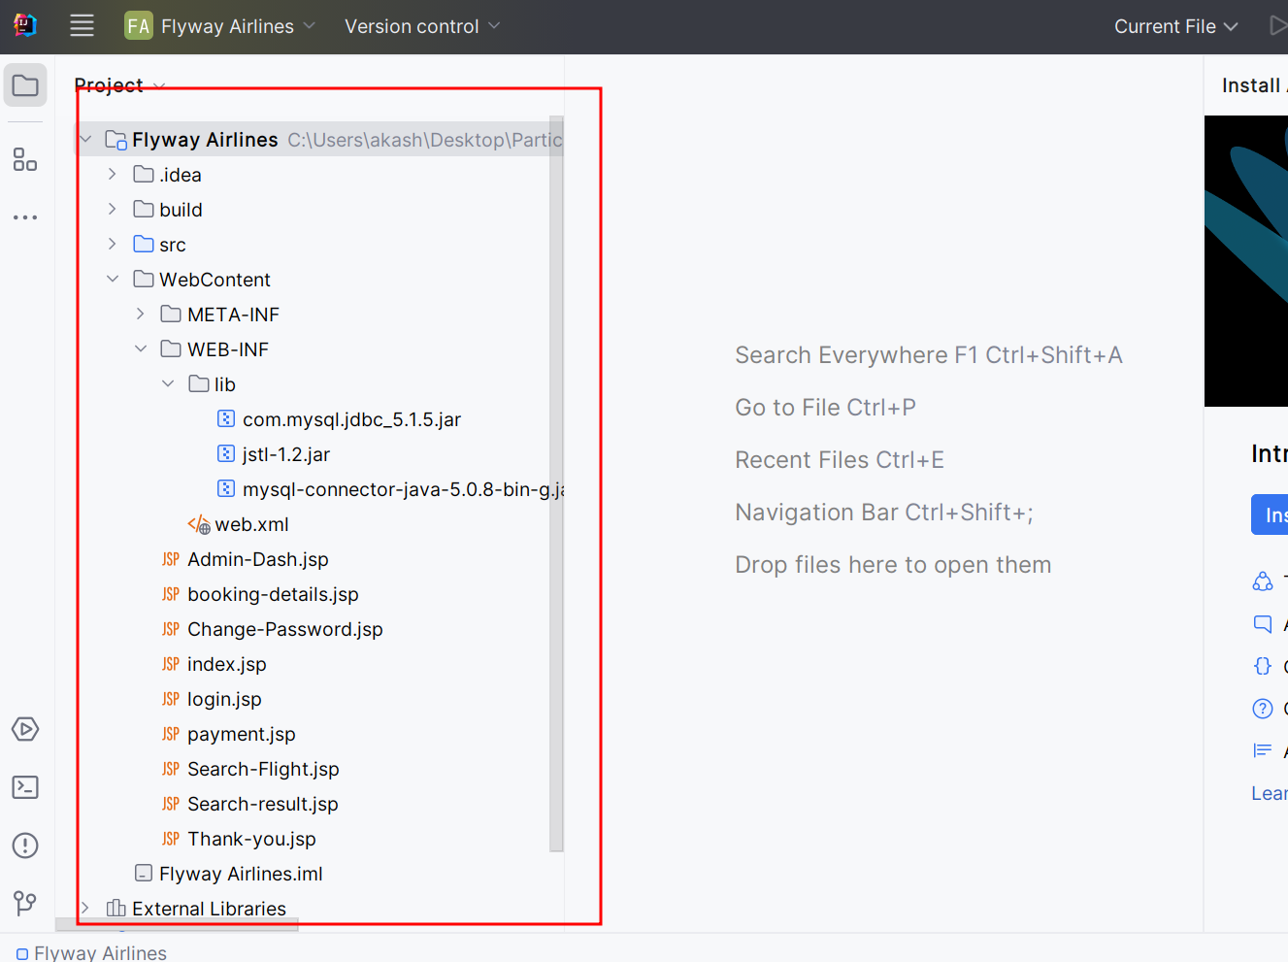

Added tomcat for this projects.

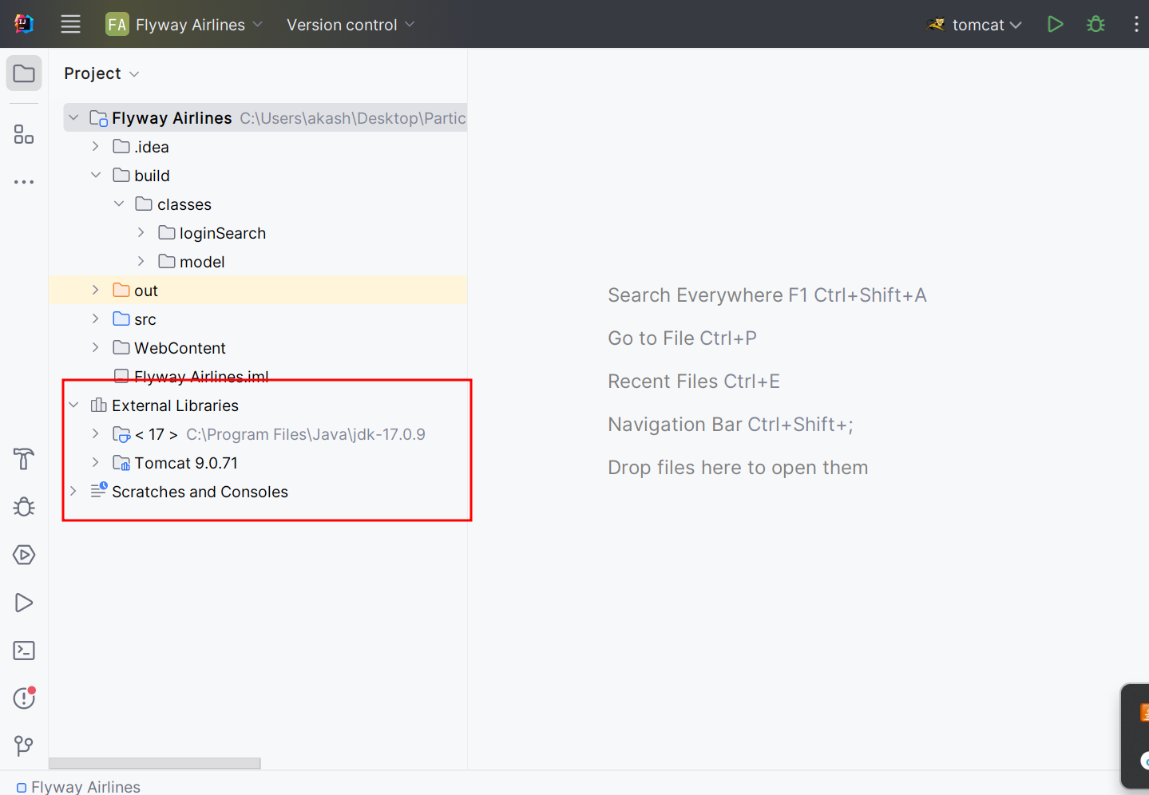

In web.xml file one error found.

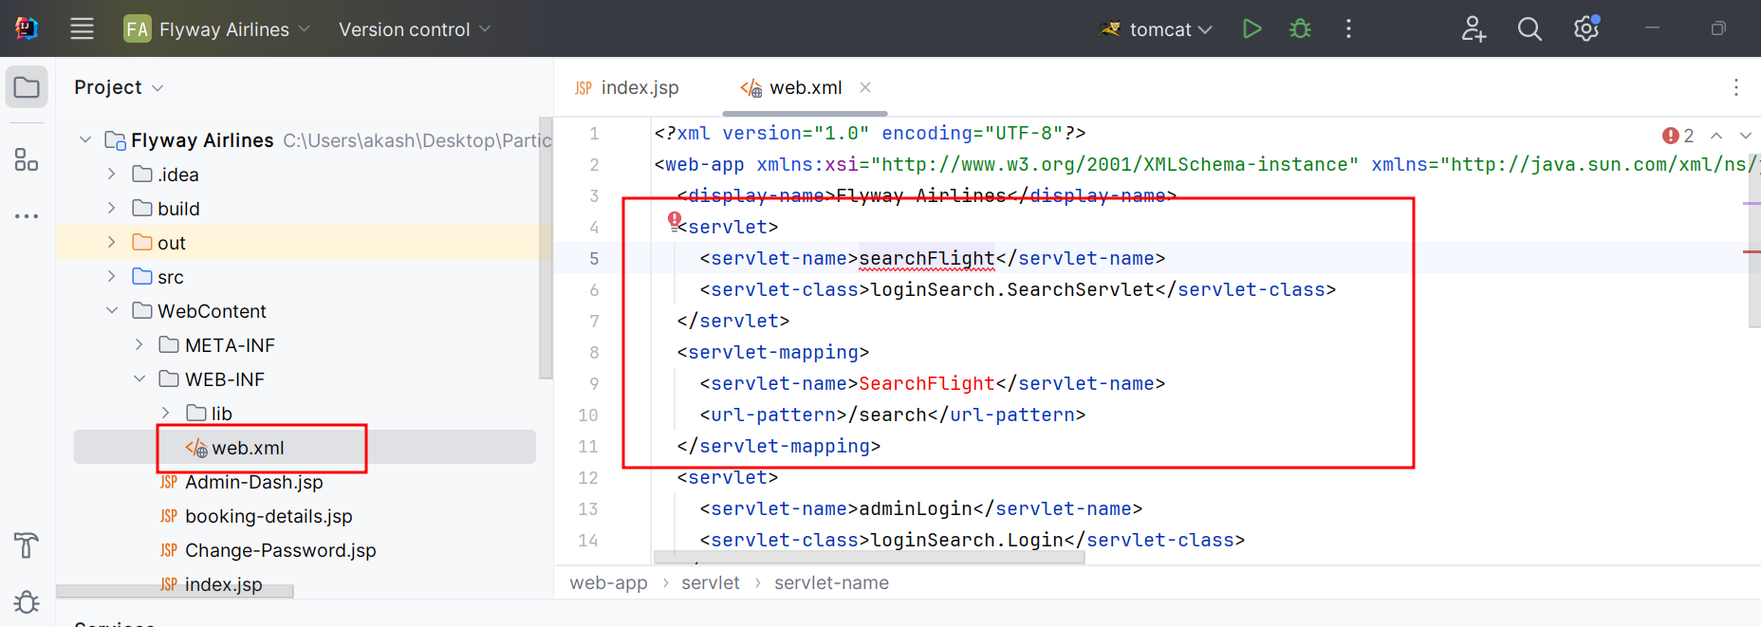

Your project not able to import in Eclipse IDE. So created new project in Eclipse IDE and copy and paste your code.

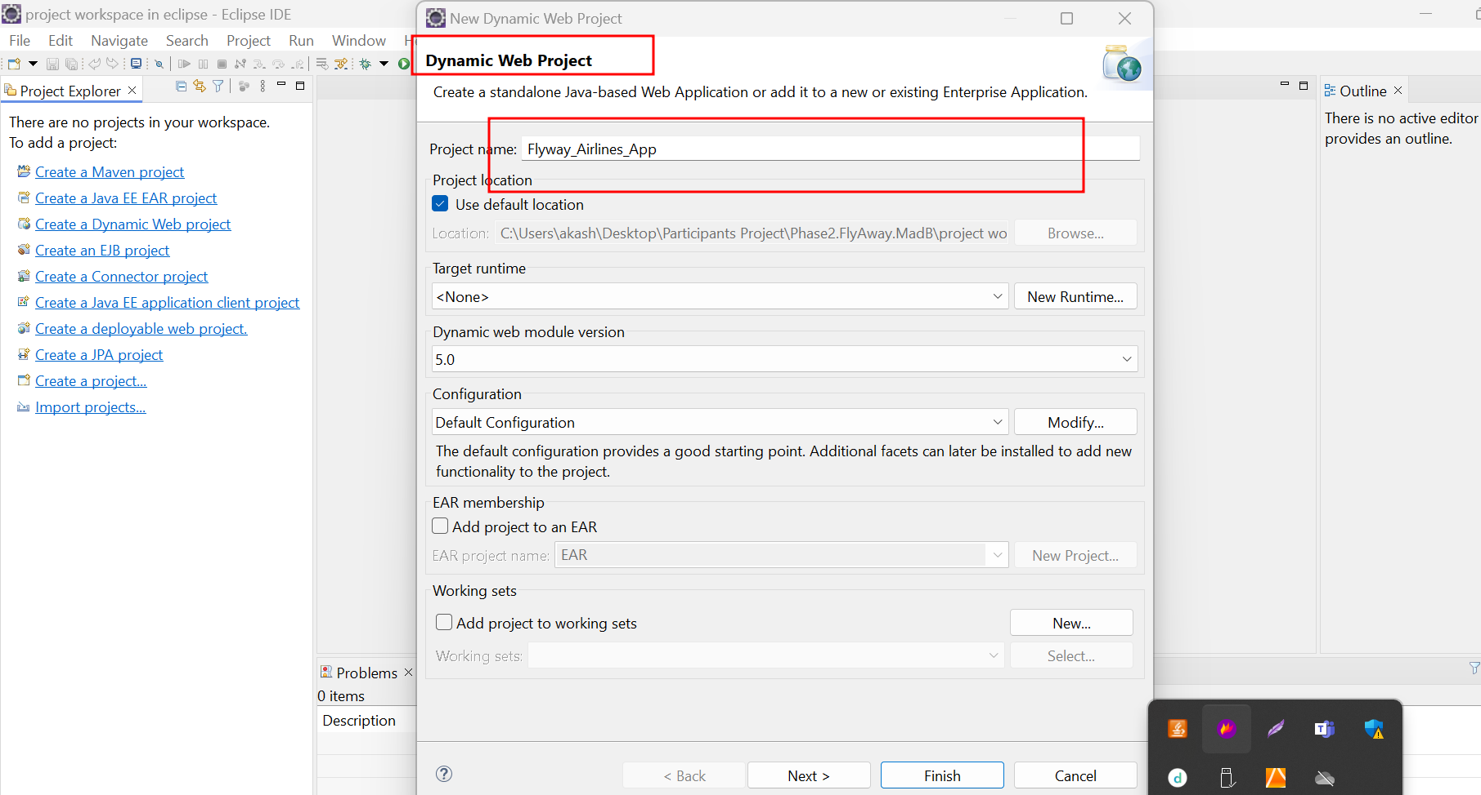

Initially we need to add the tomcat server with project version taking as 4.x version .

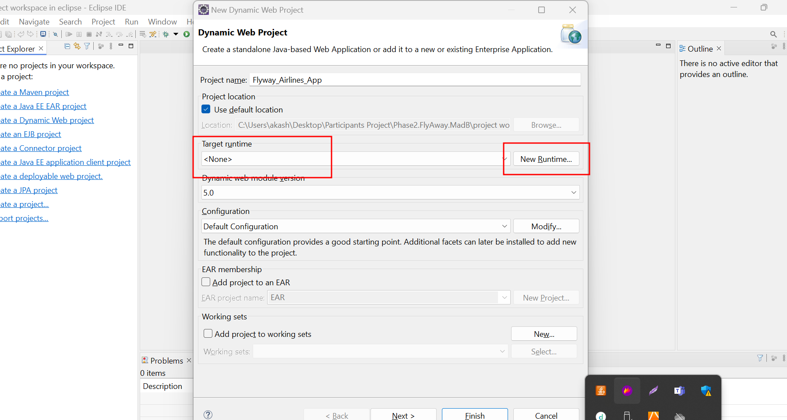

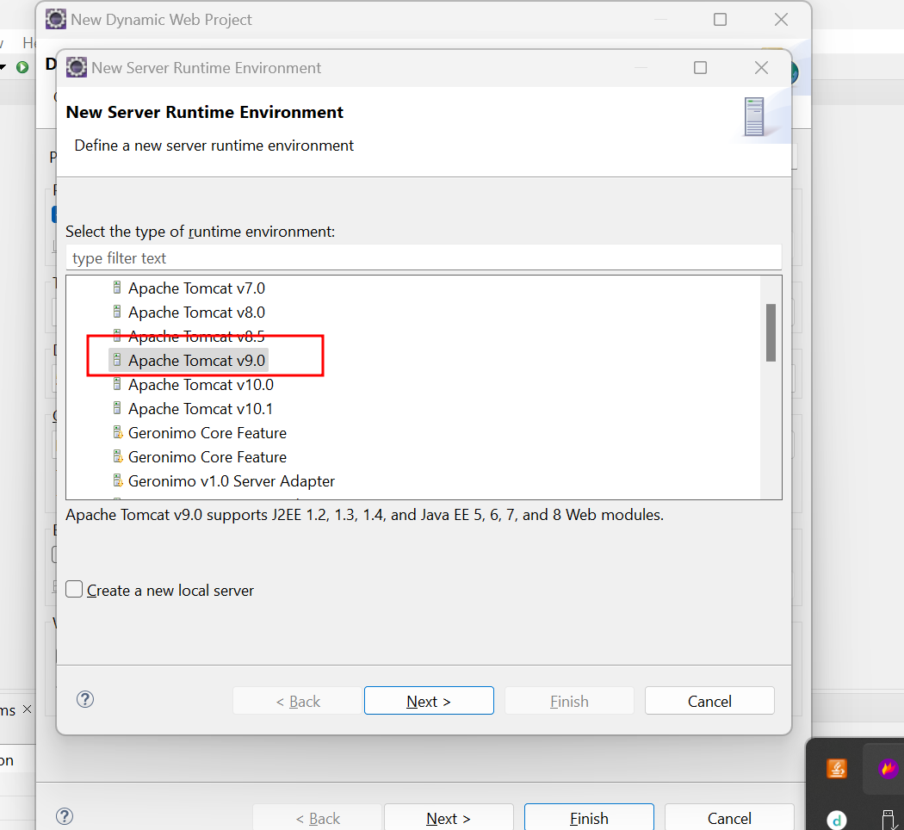

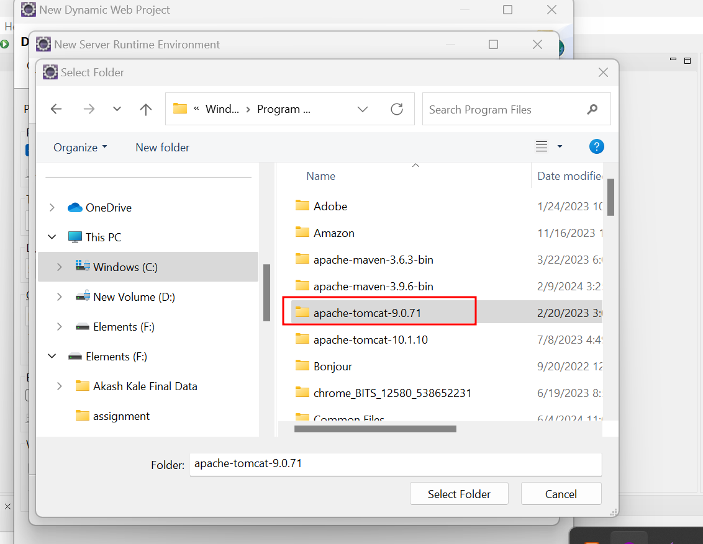

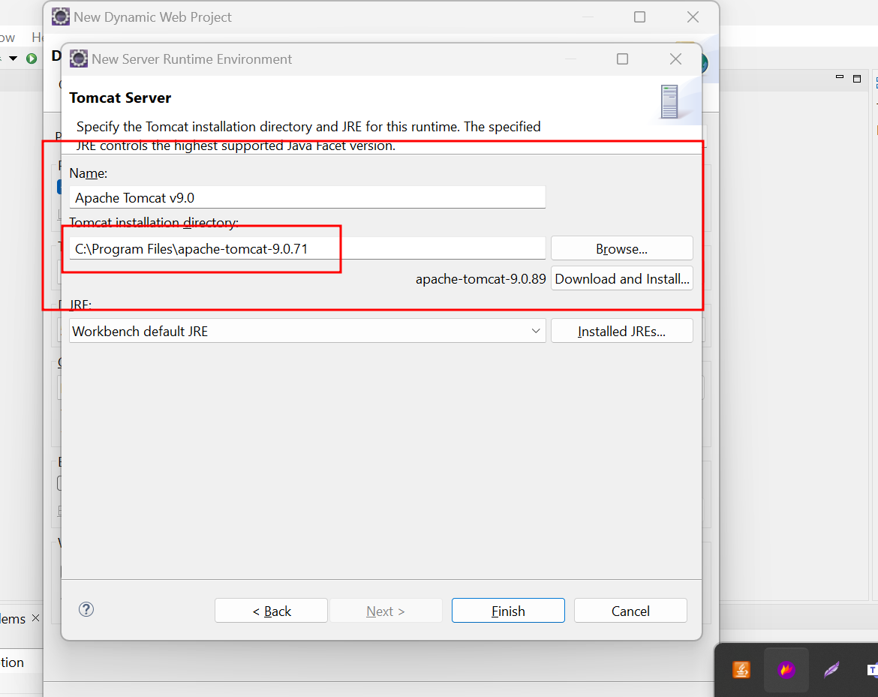

Please check your version tomcat

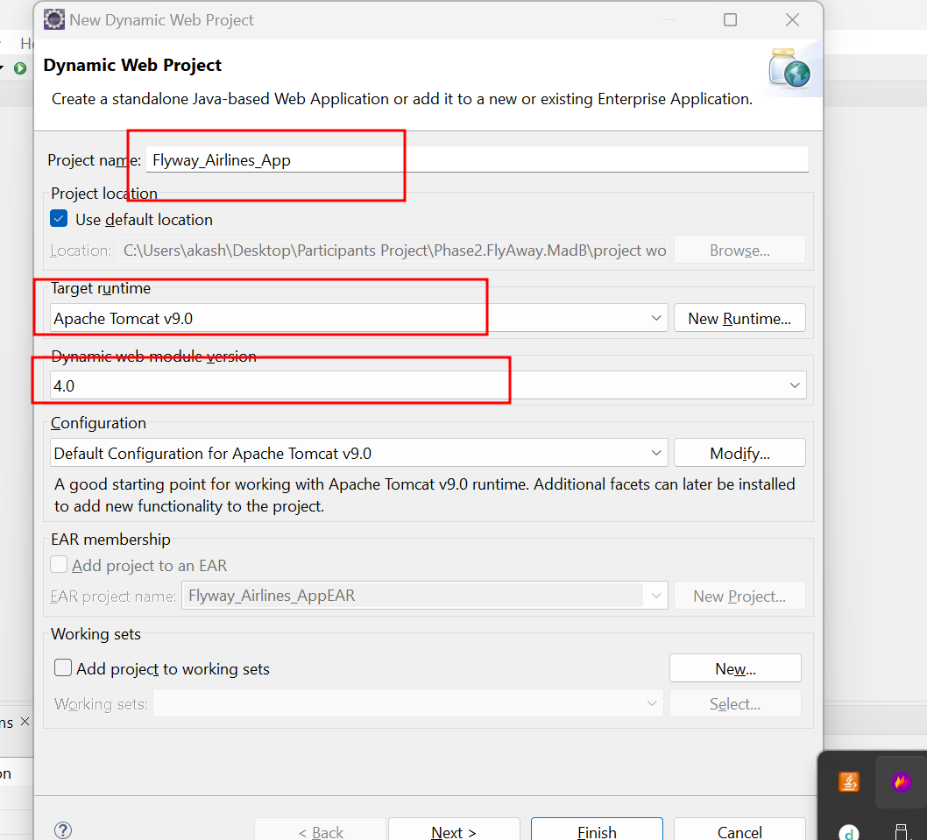

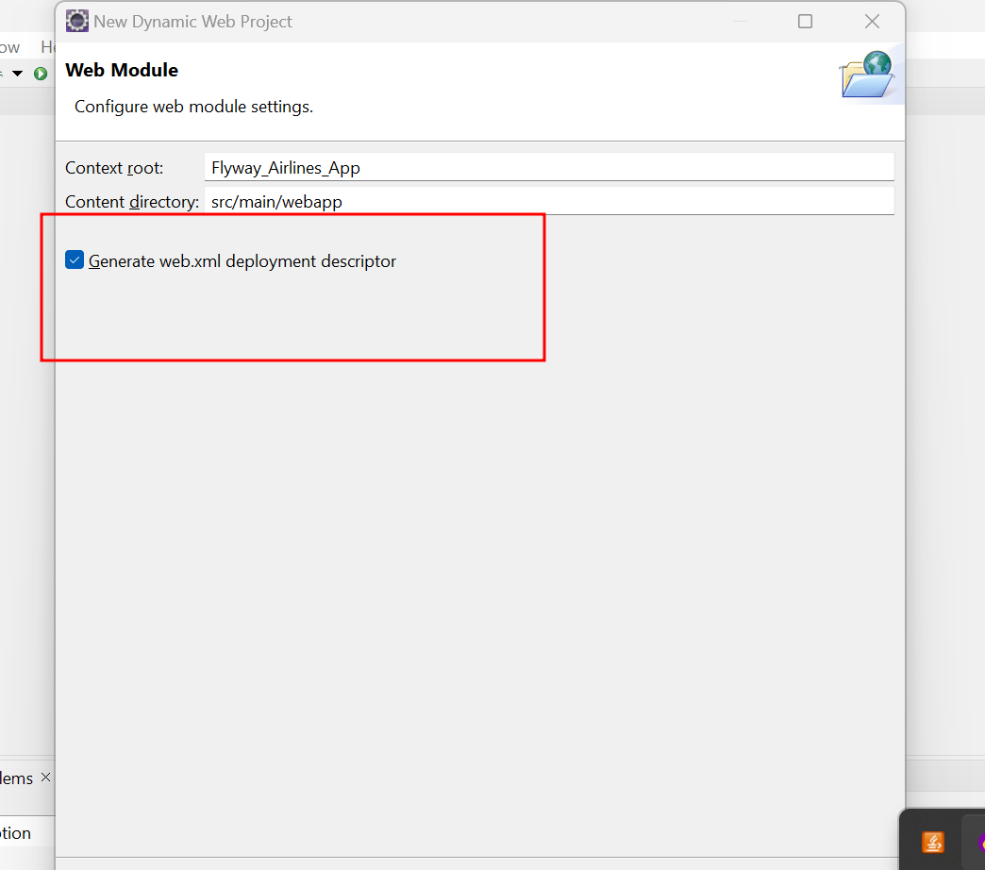

First copy all jar files inside the lib folder part of WEB-INF folder.

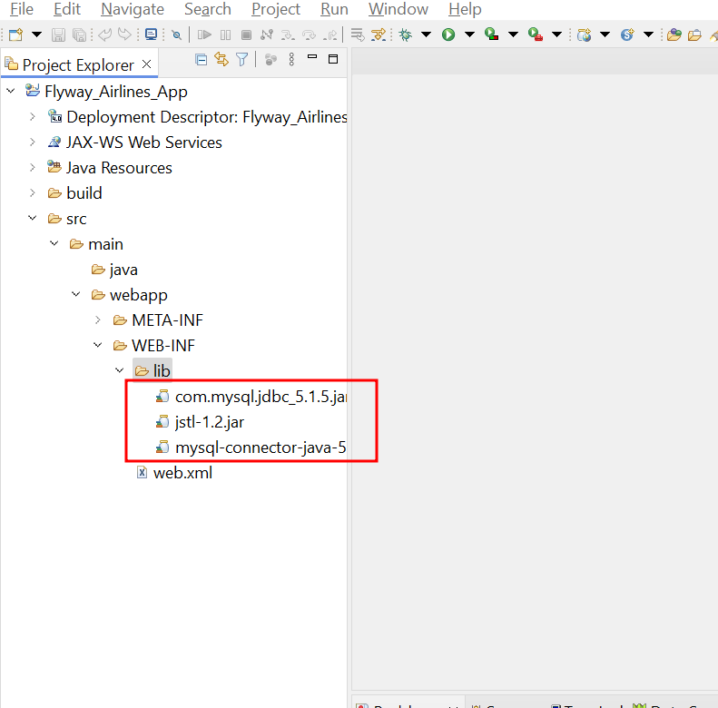

Then copy and paste all .jsp files inside the webapp folder.

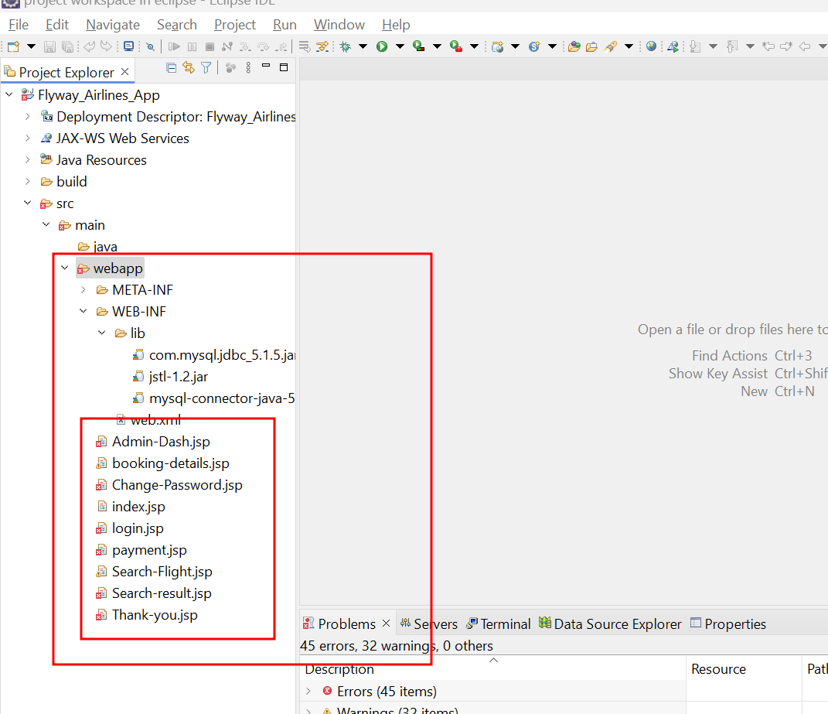

Then copy and paste model and servlet classes from src folder to new projects.

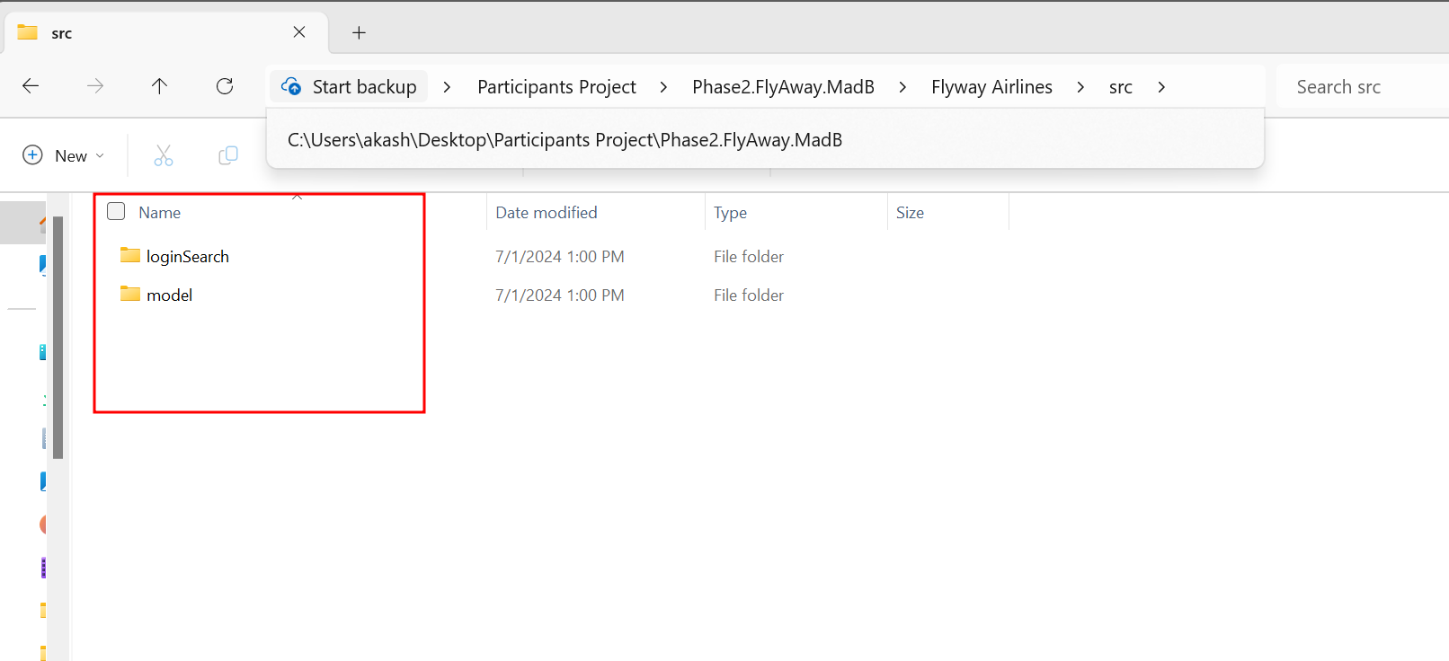

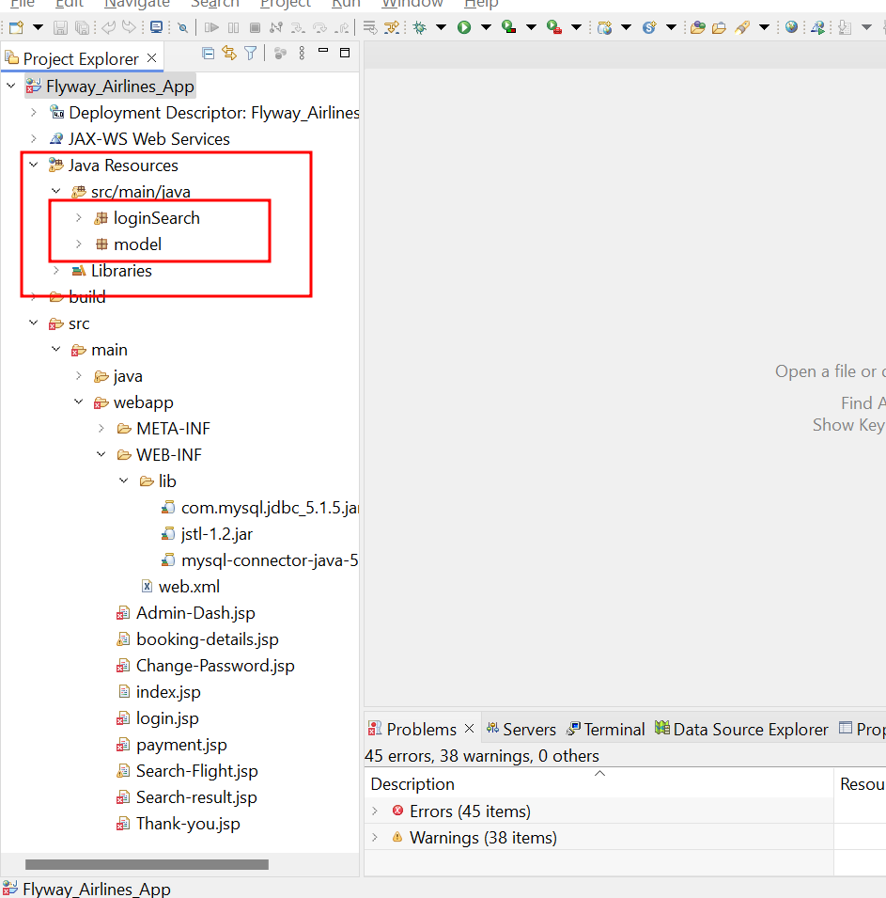

Then we need to provide each servlet program details in web.xml file

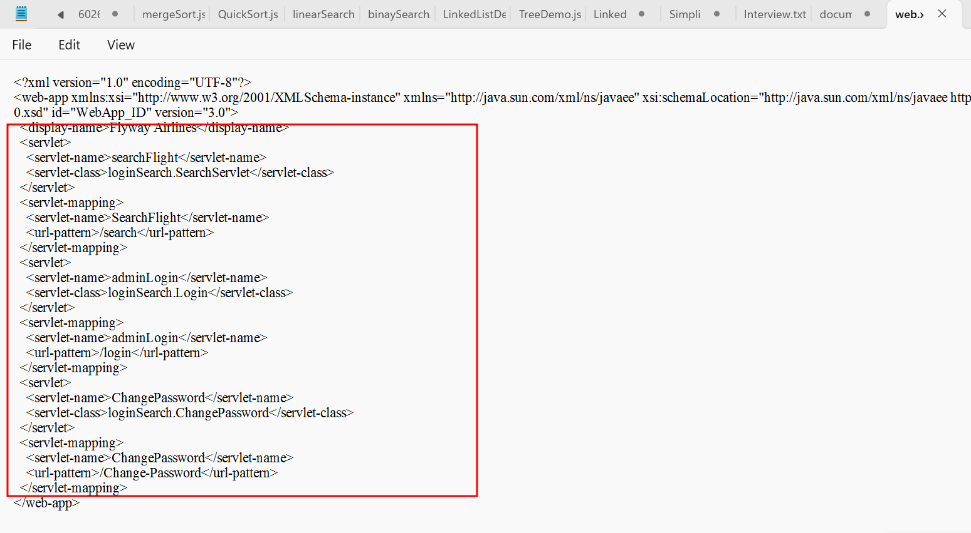

In new project web.xml file

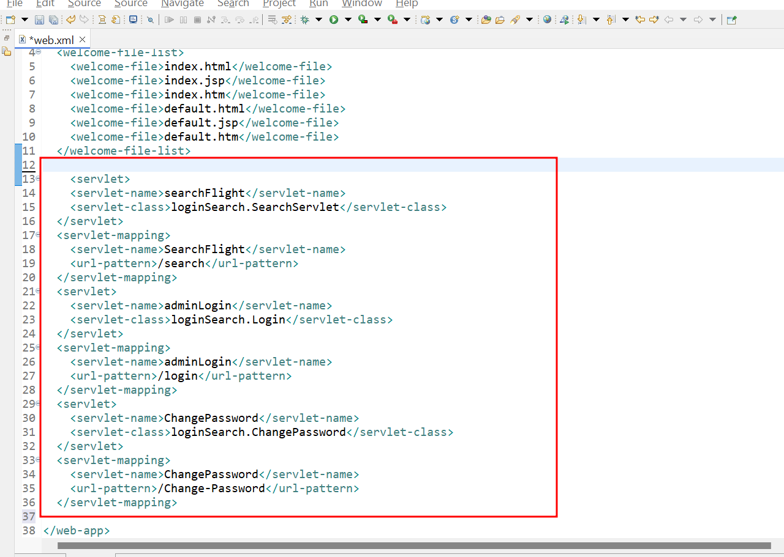

Now setup is ready. Make sure there is no error.

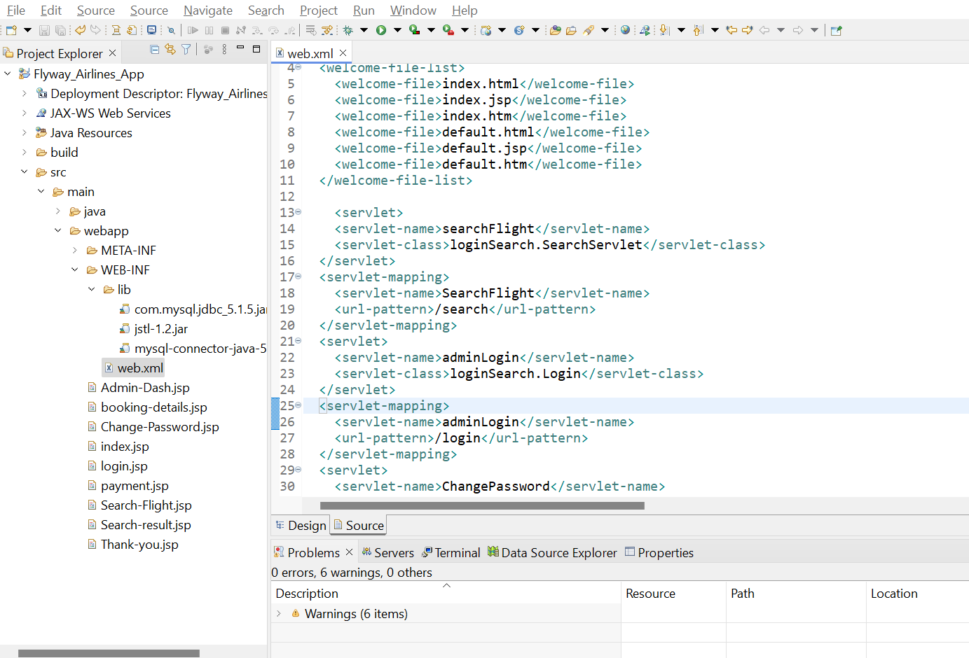

Now we need to open the database ie mysql using command prompt or workbench.

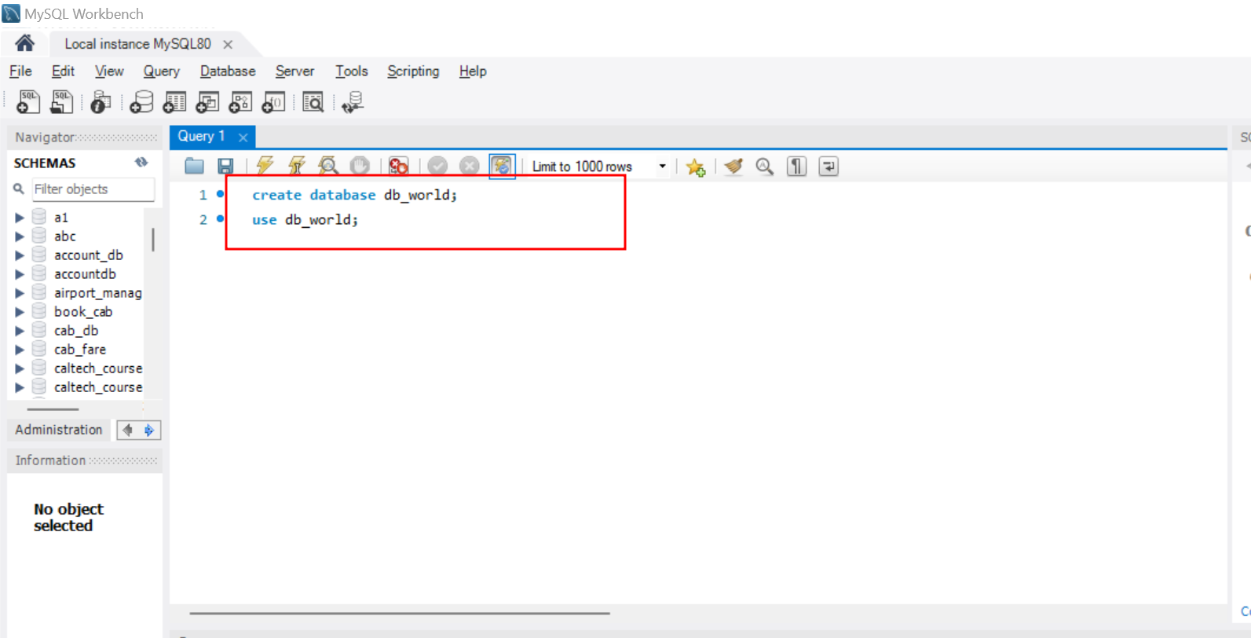

In my machine mysql username is root and password is root@123.

So I done the changes in your code as password as root@123.

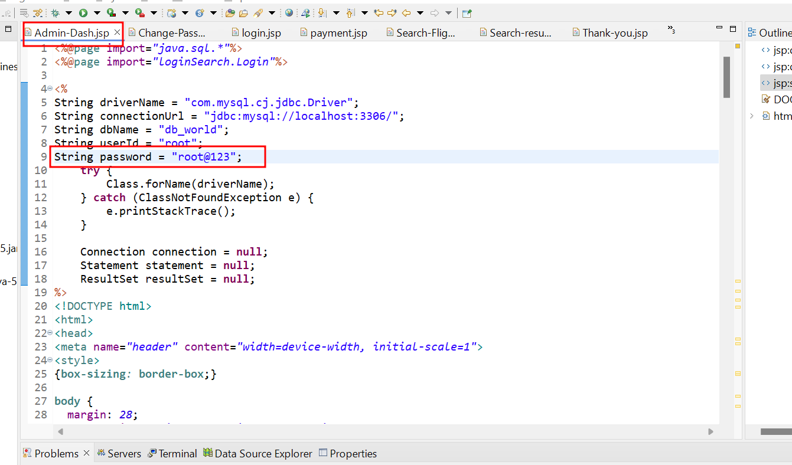

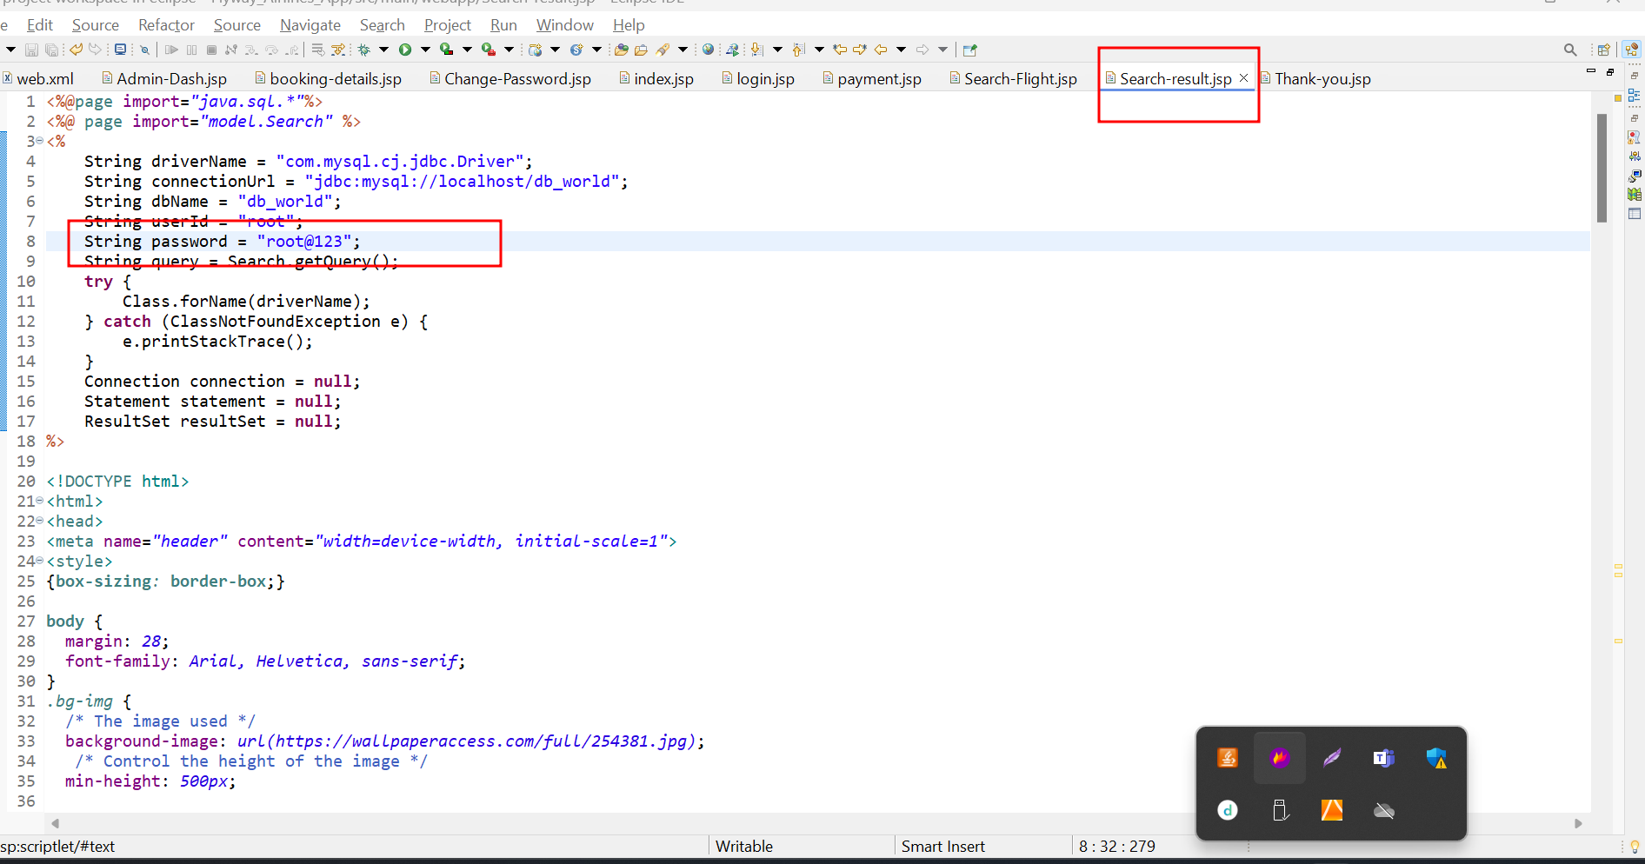

One error fond in web.xml file

S must be in upper case.

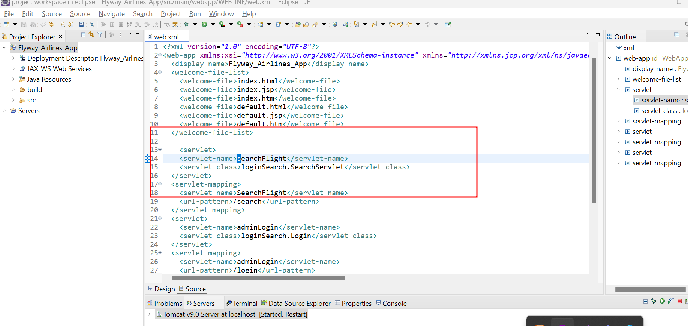

Then after run the program

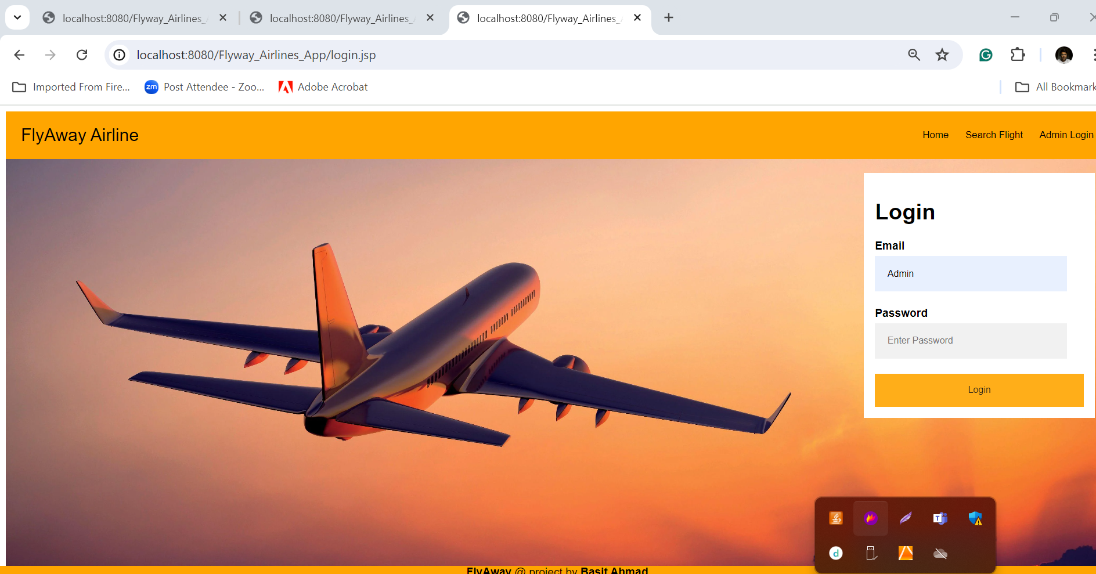

Here admin login

Emailid as [admin@Fly.com](mailto:admin@Fly.com)

Password as Admin

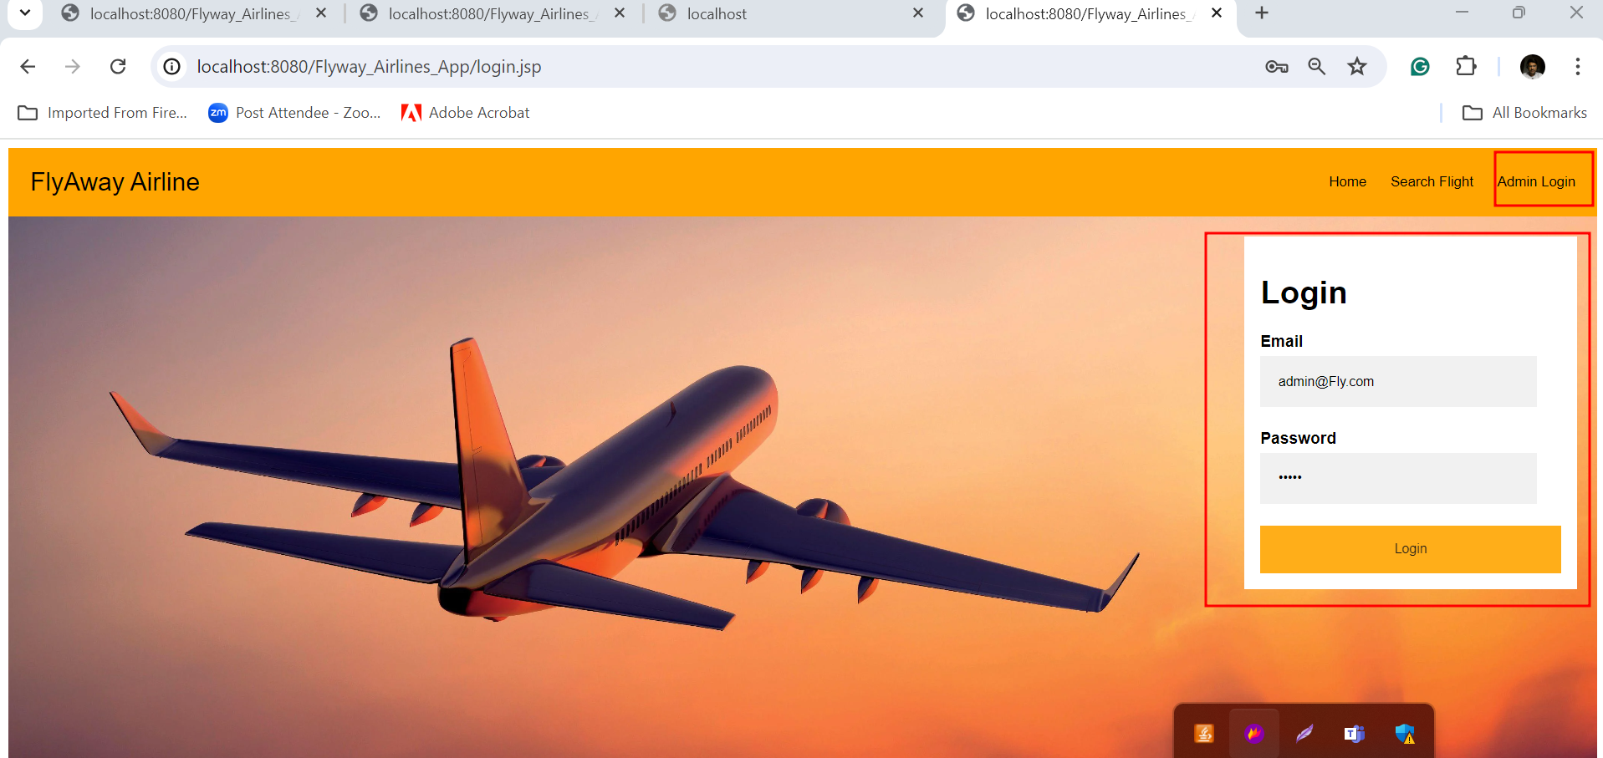

After click on login button it open the dashboard

But got the error message as database connection

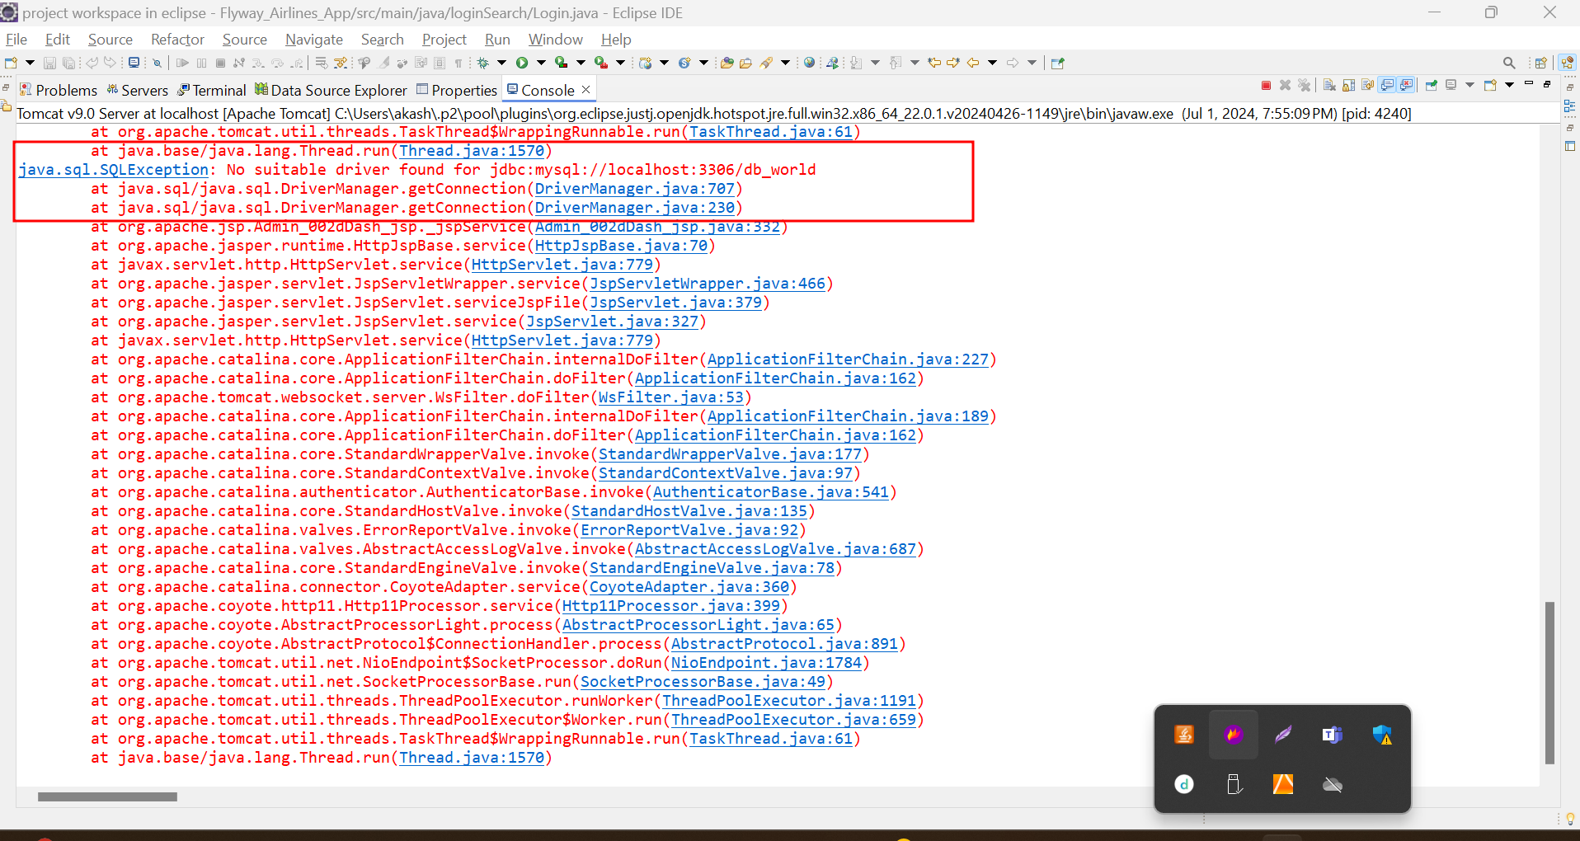

I removed both mysql jar files and added new fresh correct jar file.

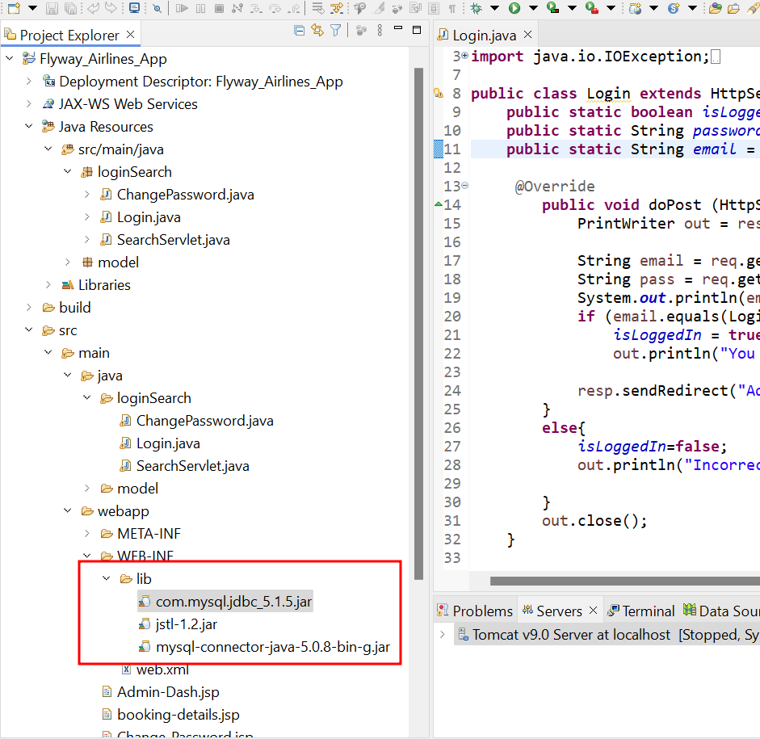

After replace mysql connector jar file

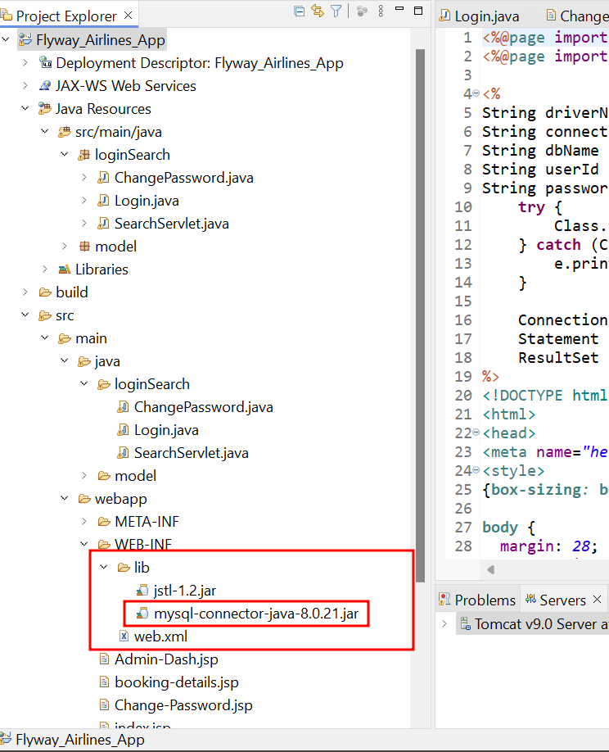

After login now we can see the another error as Flight table not exists in the db_world database.

Now we will create the table as flight.

Create flight table with below sample data.

create database db_world;

use db_world;

create table Flight(

flight_number varchar(50) primary key,

flight_name varchar(50),

source_info varchar(50),

destination varchar(50),

date_of_travel varchar(50),

ticket_price varchar(50)

);

INSERT INTO Flight

VALUES ('ABC123','Air India','Delhi','Bangalore','1-Aug-2024',8500),

('ABC987','IndiGo','Pune','Bangalore','2-Aug-2024',6900),

('XYP023','SpiceJet','Bangalore','Hyderbad','4-Aug-2024',6500),

('XCF123','Air India','Delhi','Hyderbard','6-Aug-2024',12500),

('PRA172','IndiGo','Delhi','Bangalore','2-Aug-2024',13600),

('JKL980','Air India','Pune','Bangalore','8-Aug-2024',10500),

('QR340','SpiceJet','Chenai','Bangalore','10-Aug-2024',4500),

('STH650','Air India','Delhi','Mumbai','4-Aug-2024',12500);

select * from flight;

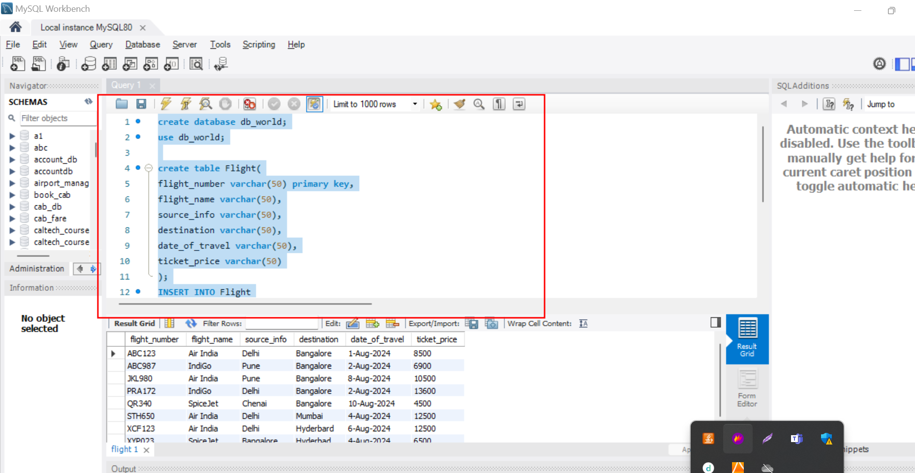

After table ready you can do the login now you can see the output on eclipse IDE. No error.

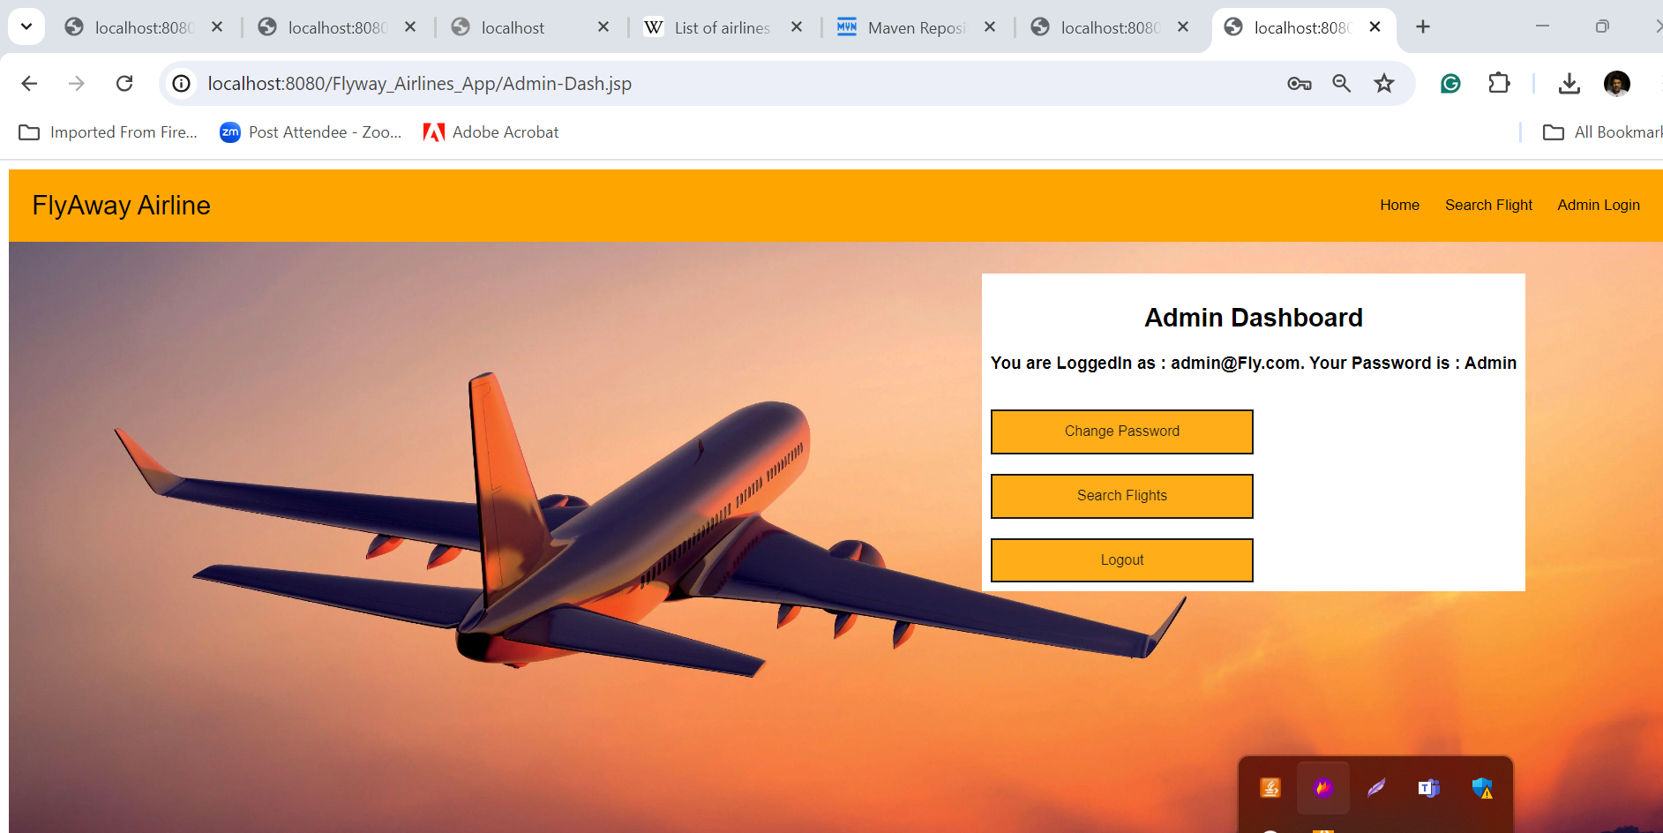

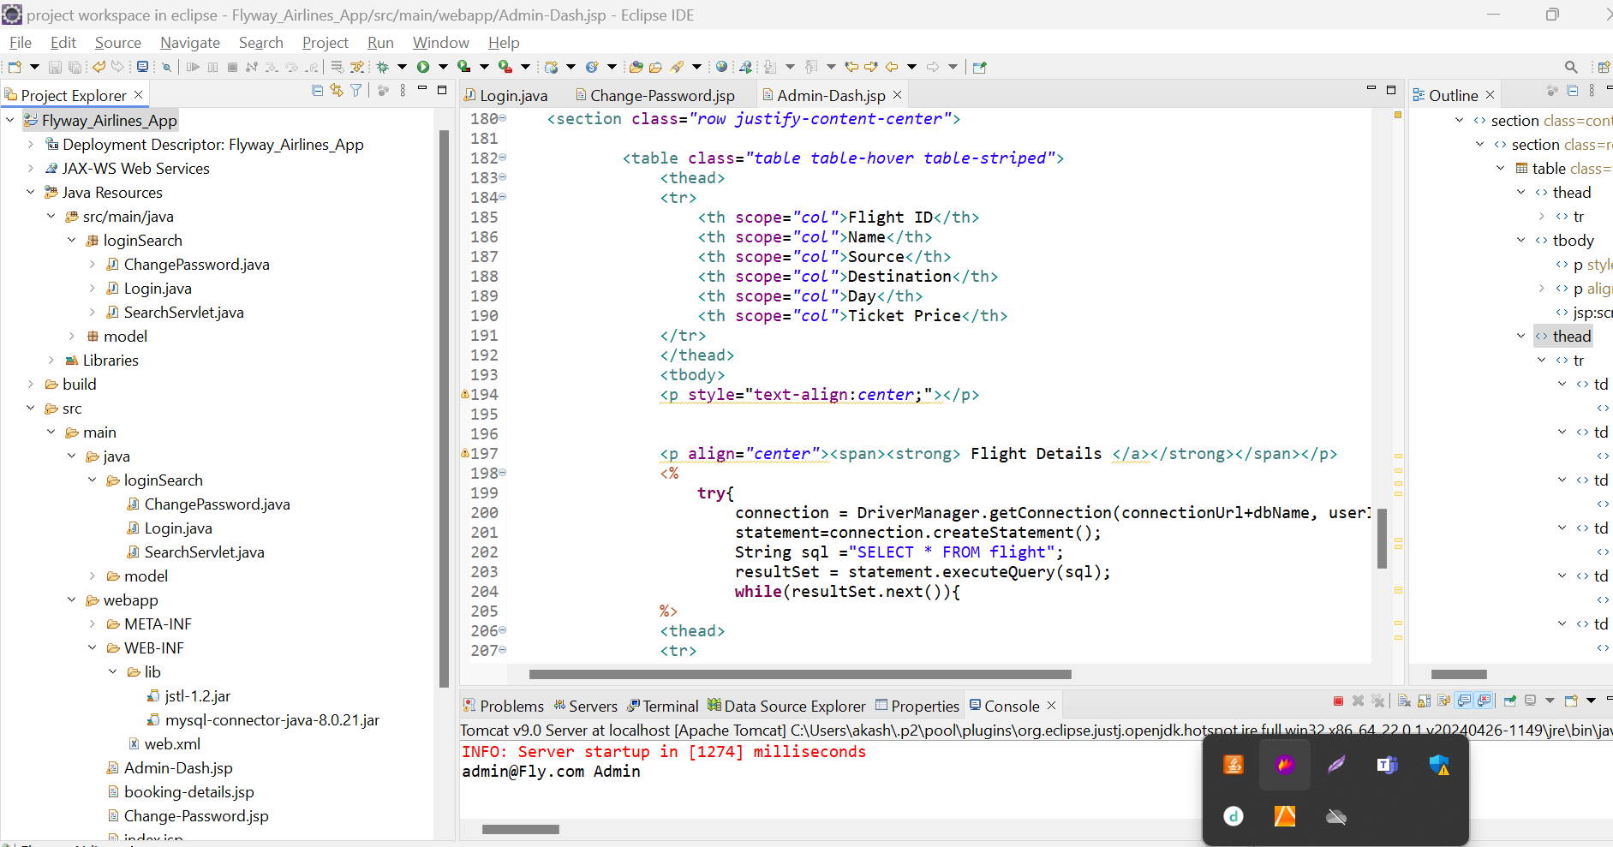

Now we will do the search flight.

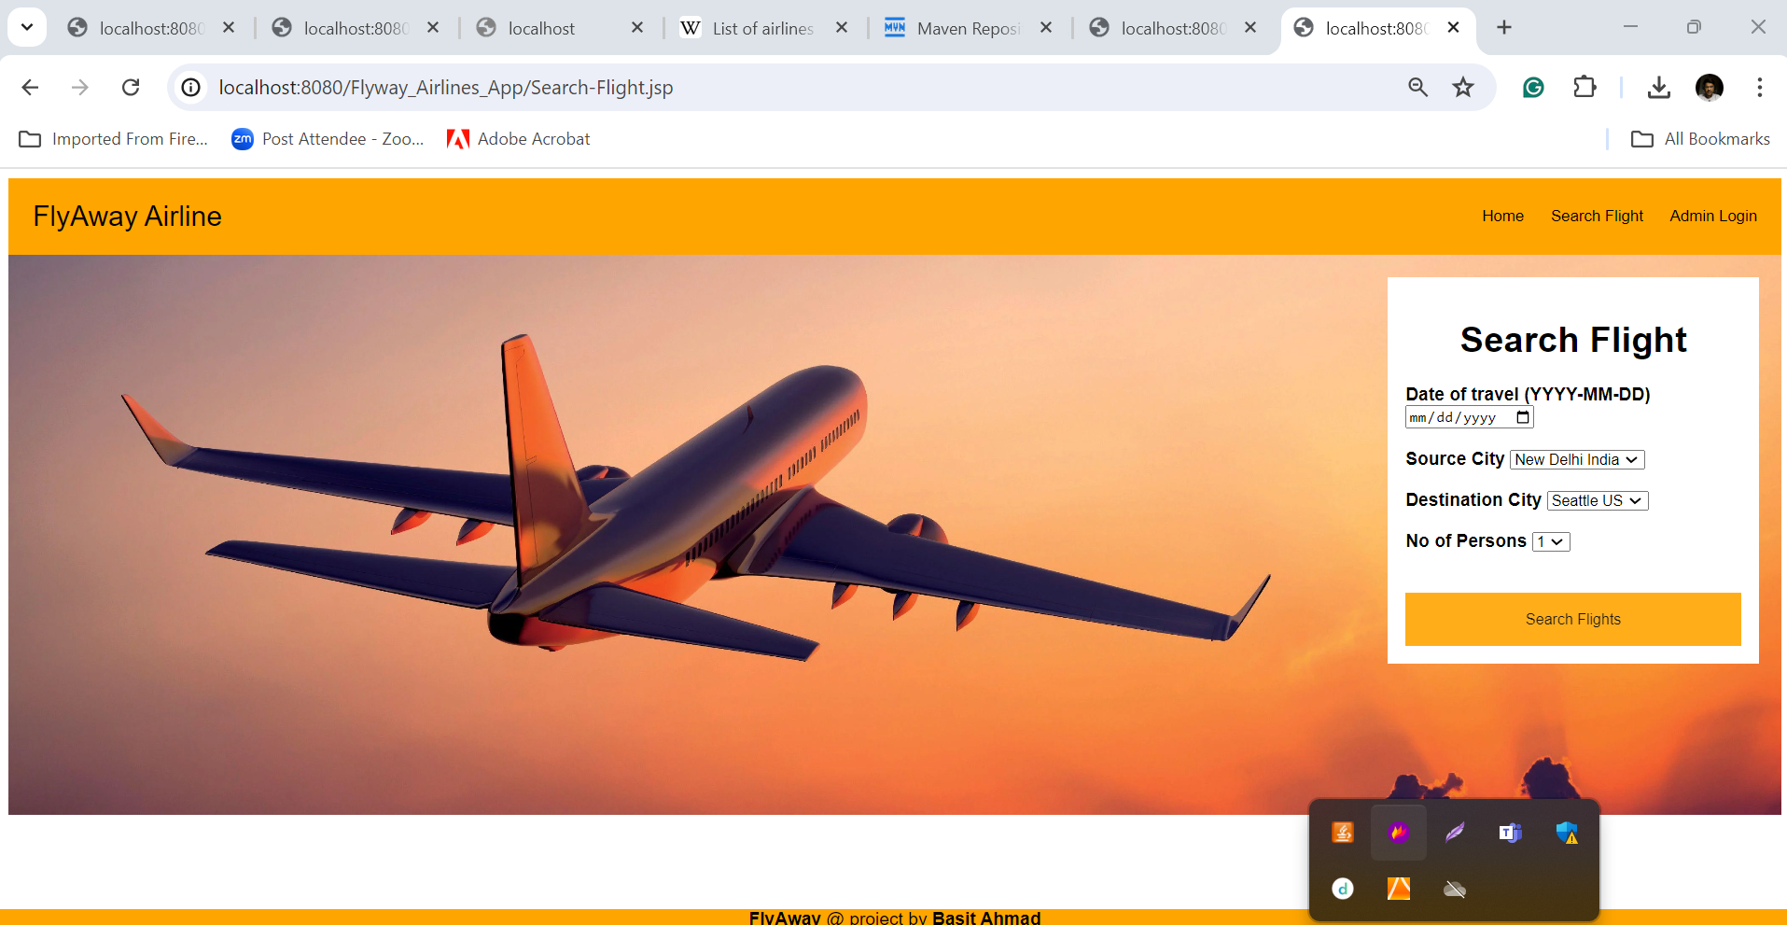

But in drop down loaded static data which is not present in table.

So we need to the changes in source destination we need to add the Search-Flight.jsp page.

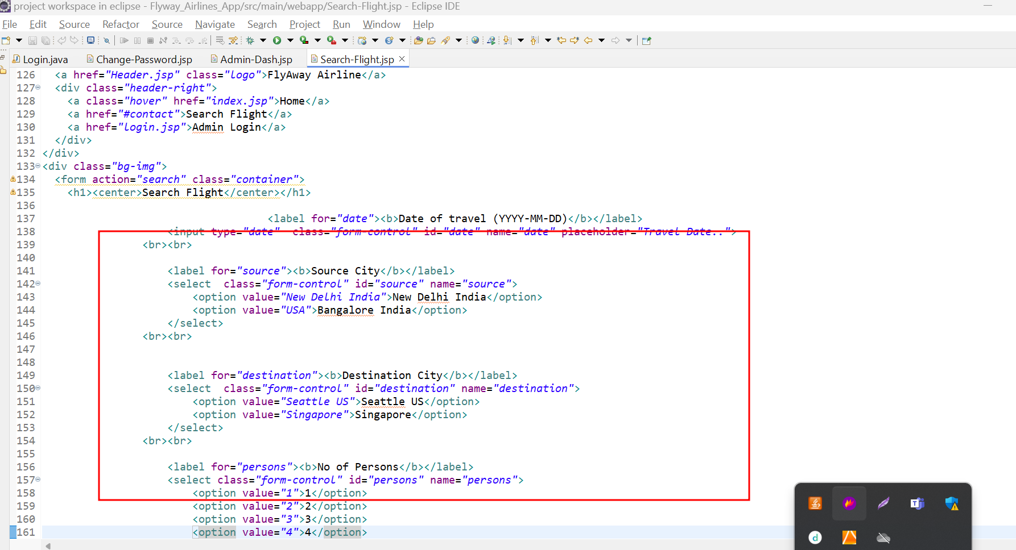

Do the changes according to data present in tables.

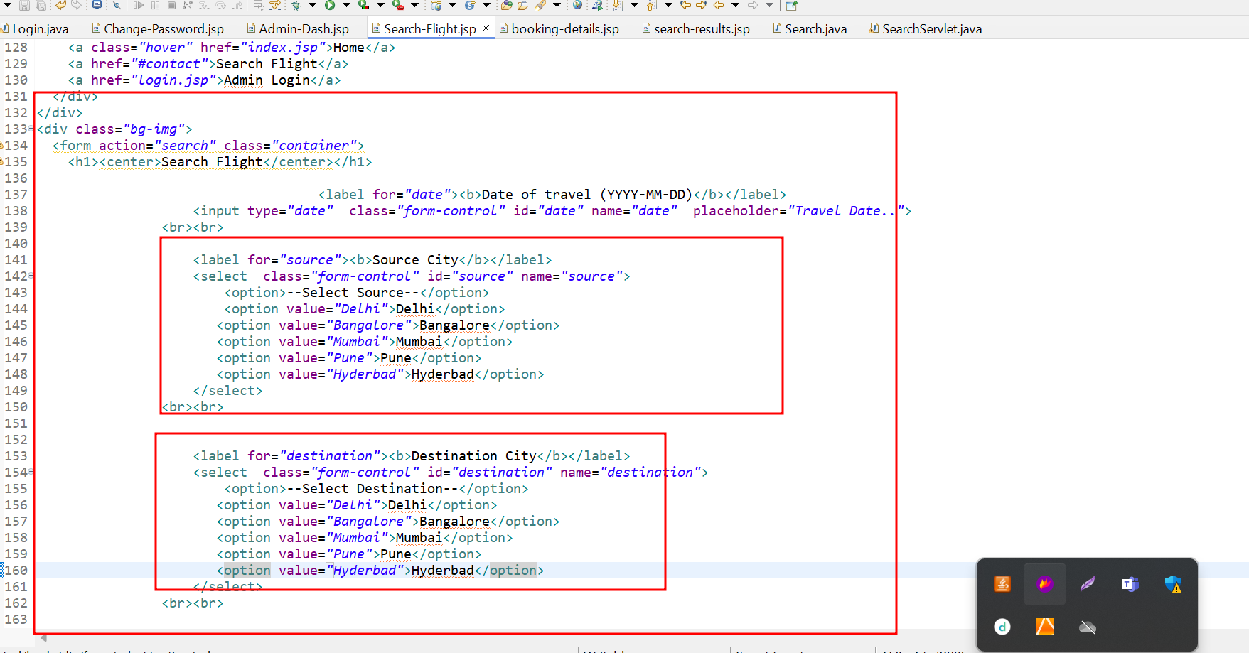

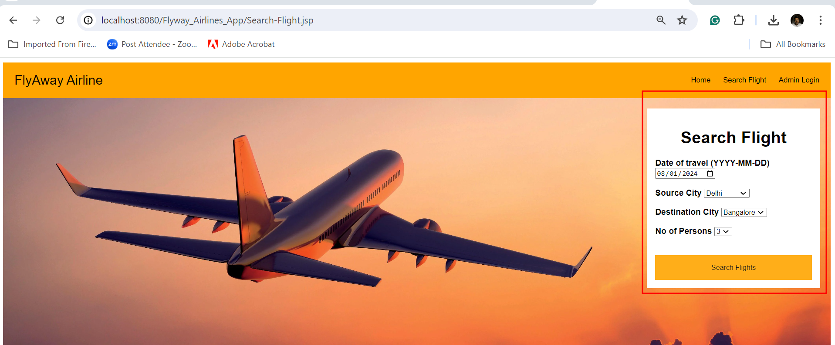

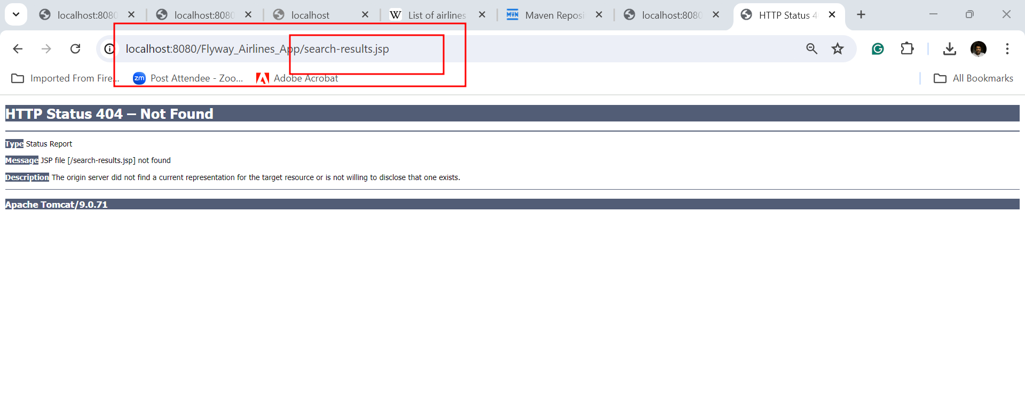

Here the file name is search-results.jsp but file present is search-result.jsp. So I rename this file name.

Then getting the error

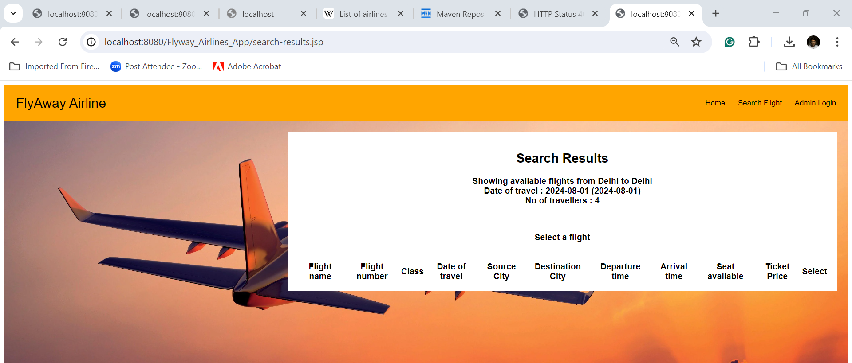

So when I search the details inside the file as search-flights.jsp

Here you use twice database name.

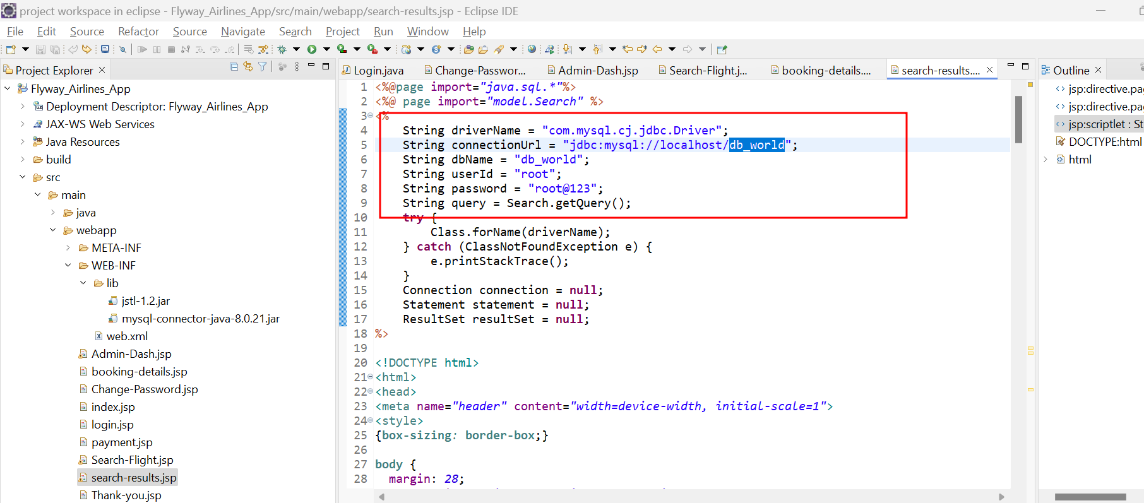

After change

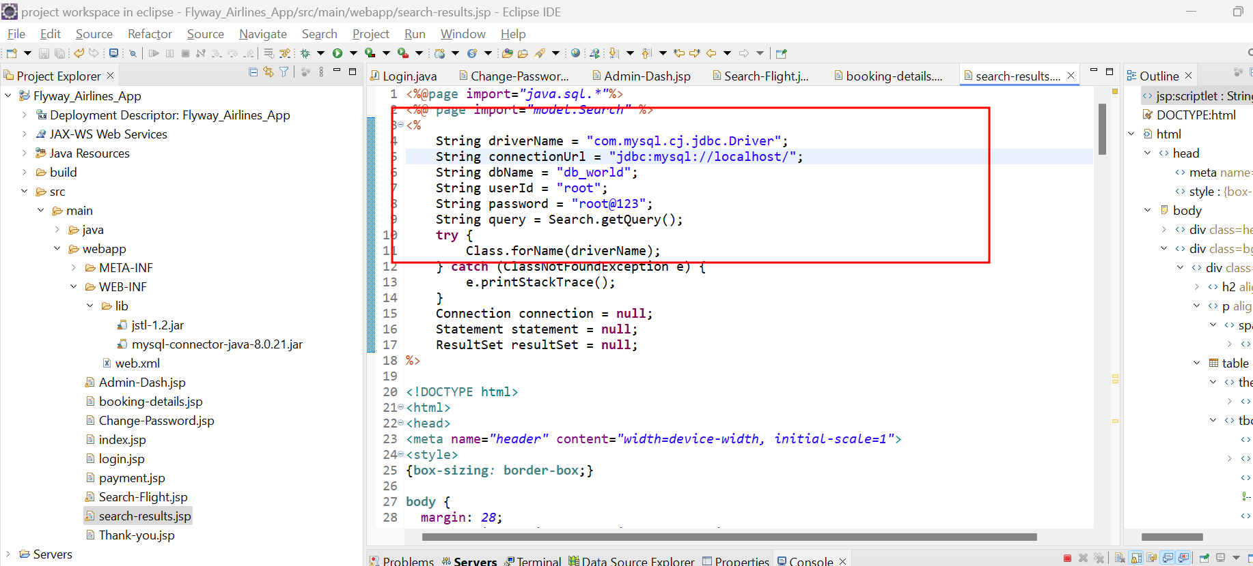

I done the changes in Search.java class

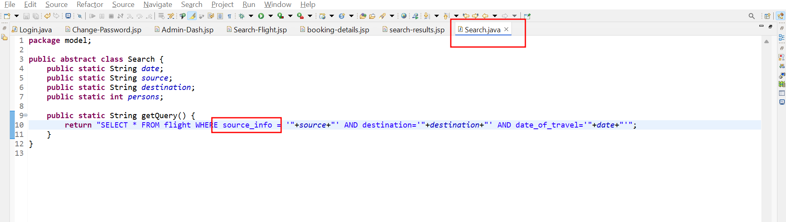

Source column name as source_info because source is keyword in mysql database we can’t use it.

Here file name is Search-result.jsp but page is moving to search-.jsp make sure case sensitive.

So here I am doing the changes in file with case sensitive.

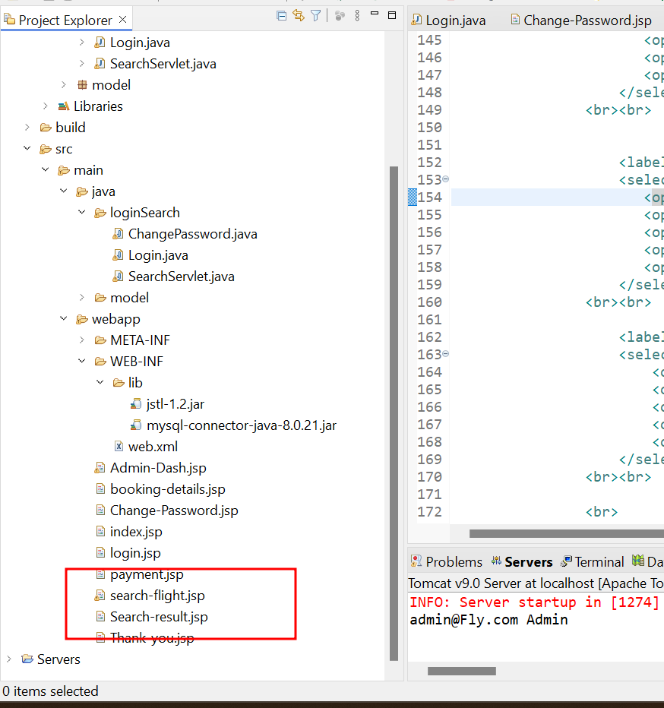

Here we need to do the changes in search-flight.jsp as

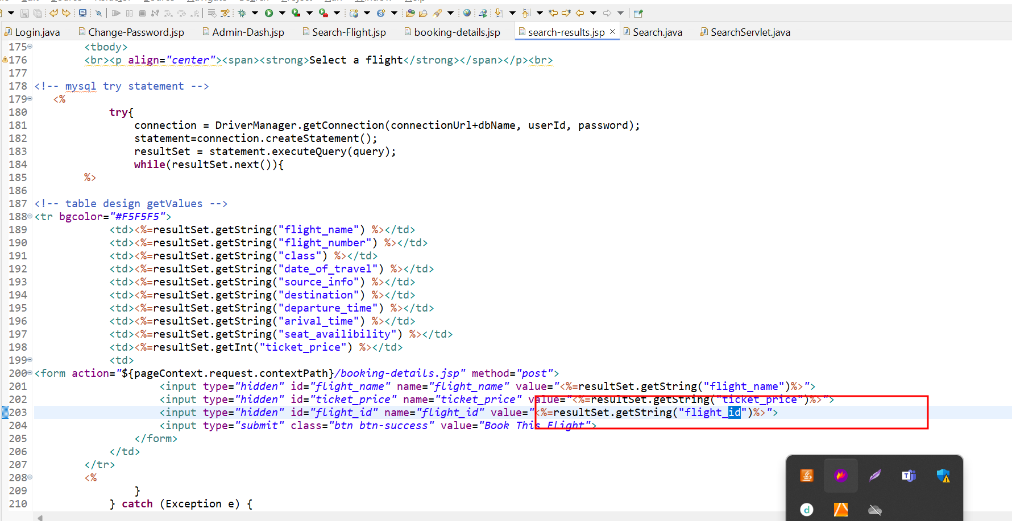

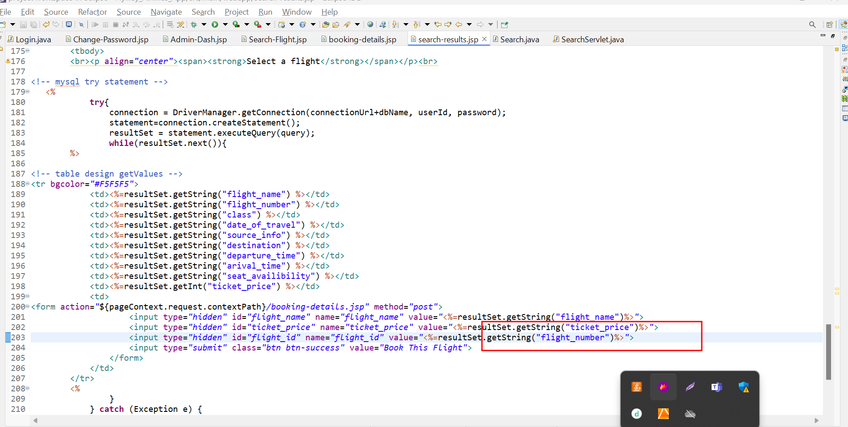

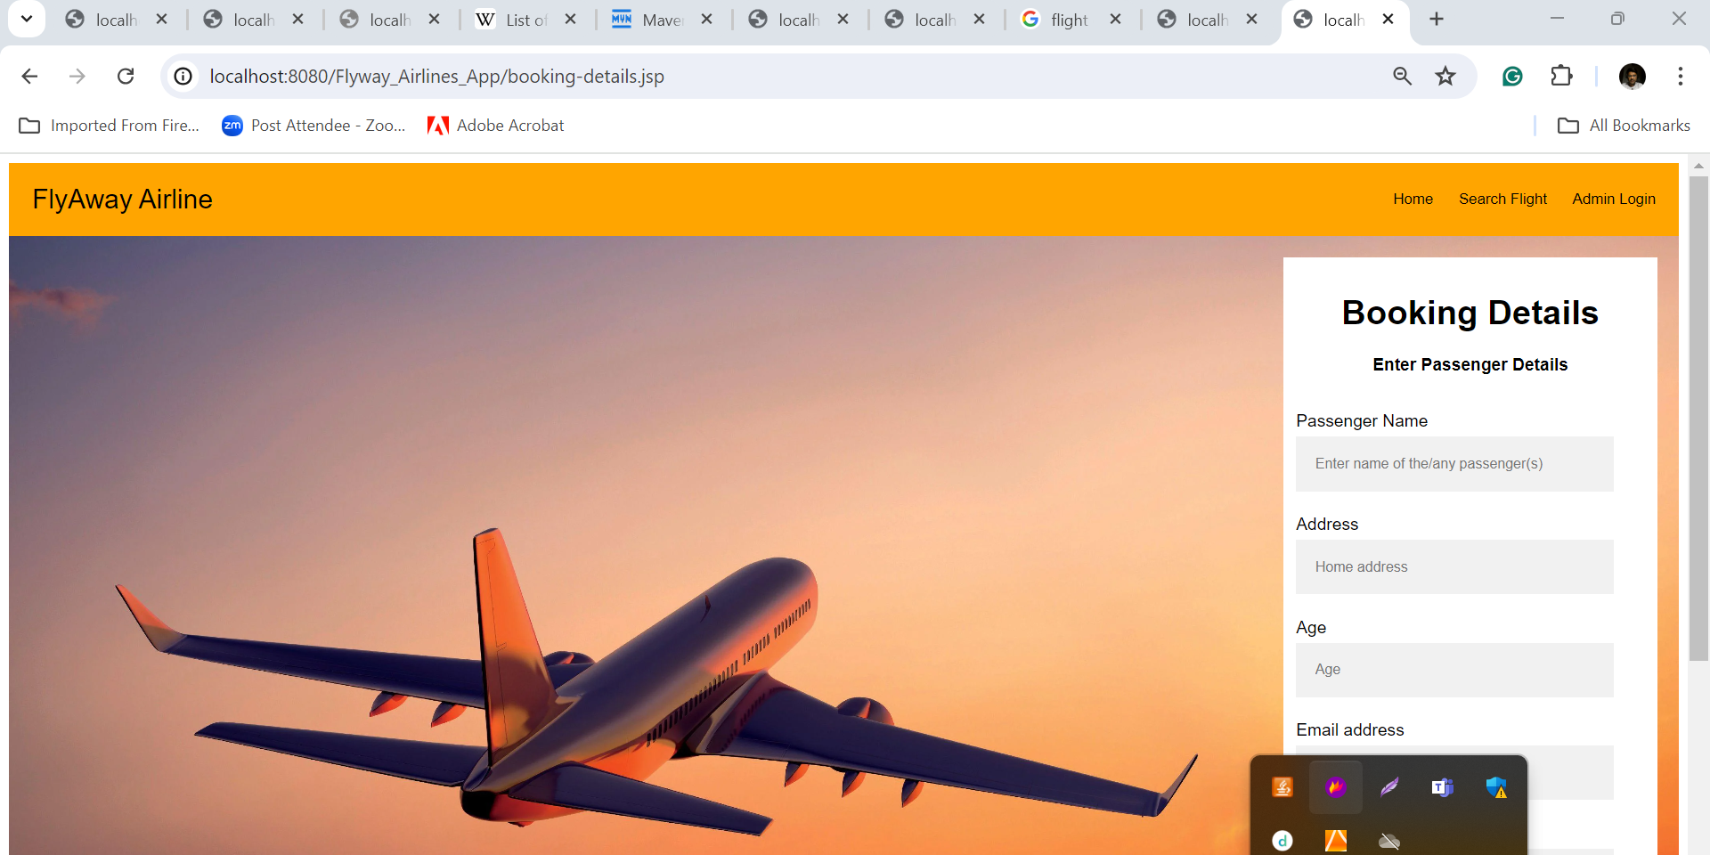

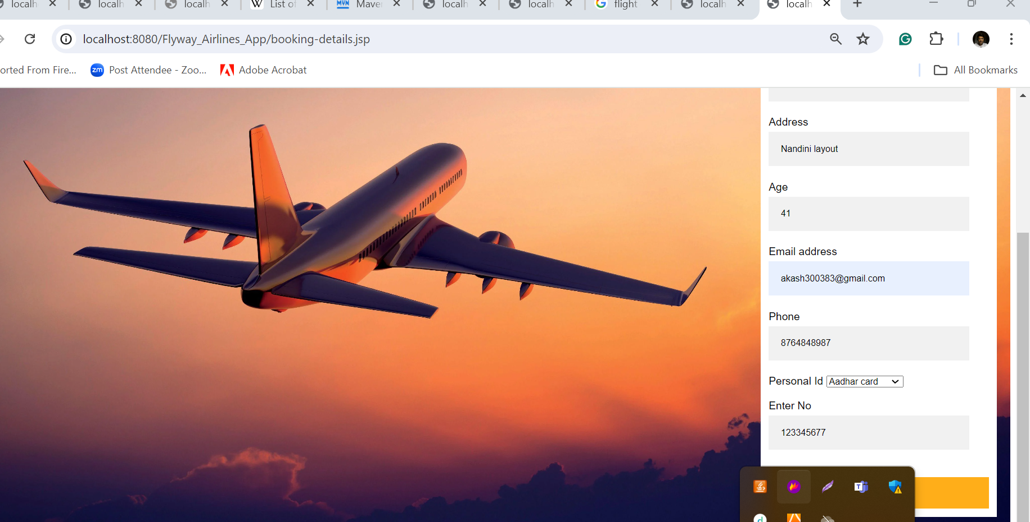

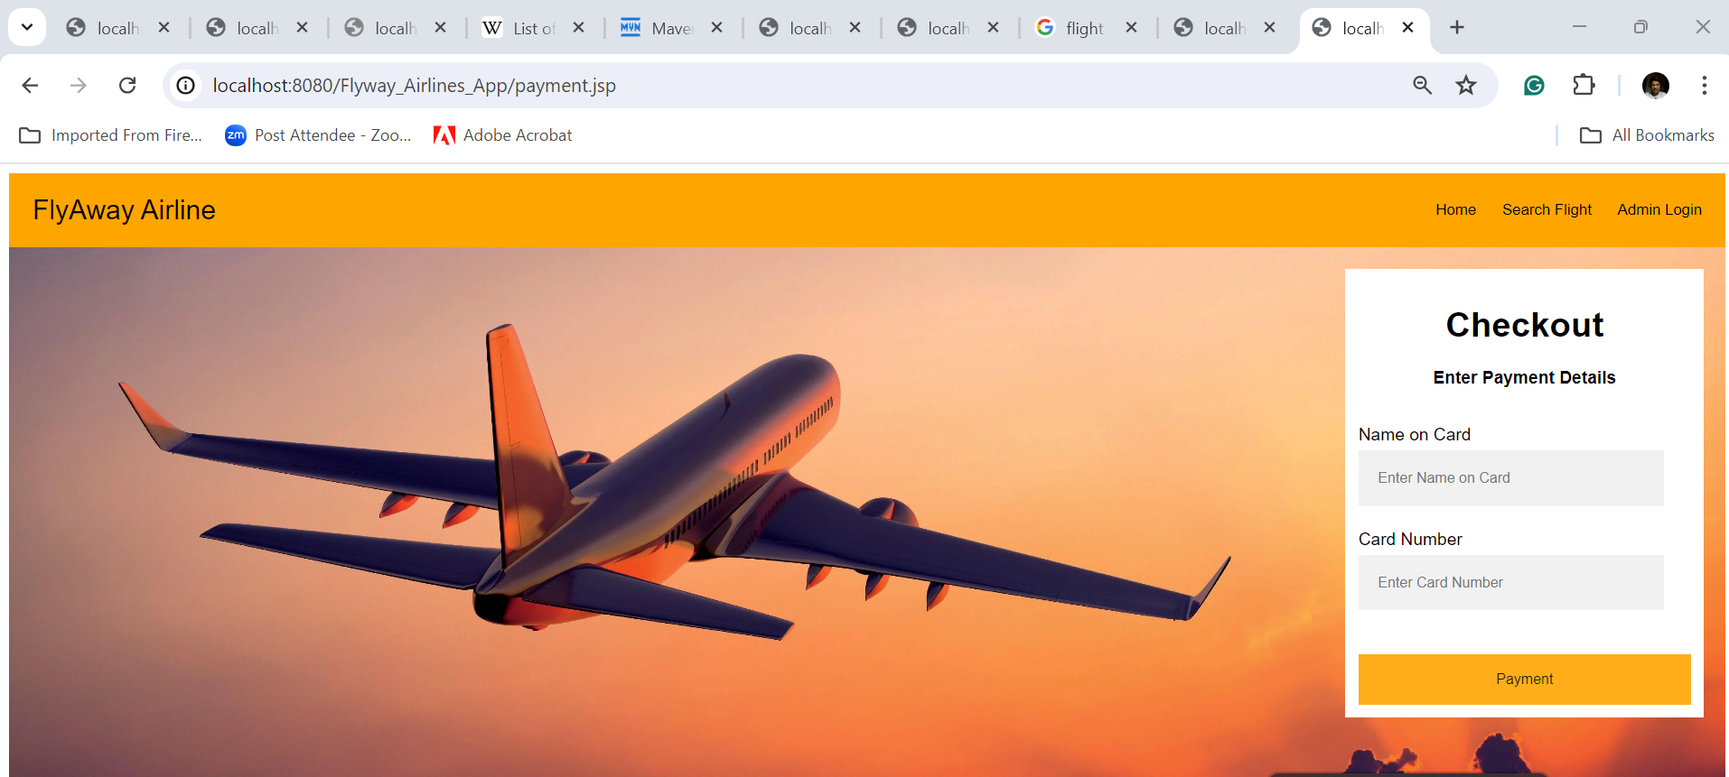

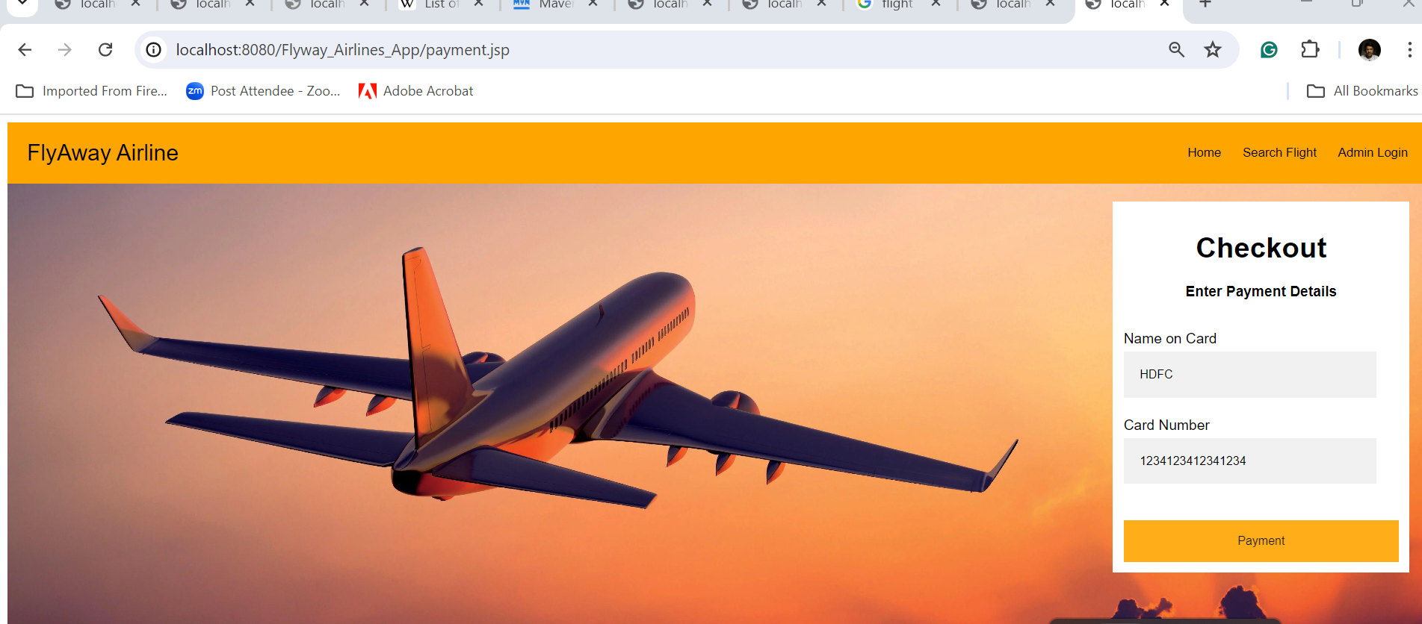

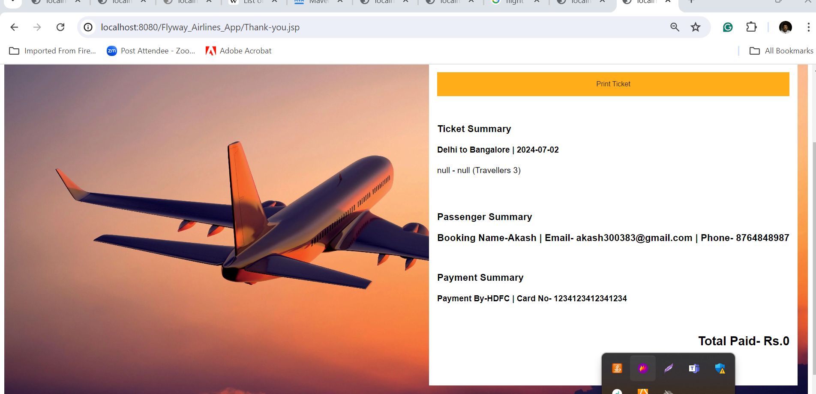

Table details

create database db_world;

use db_world;

create table Flight(

flight_number varchar(50) primary key,

flight_name varchar(50),

class varchar(50),

source_info varchar(50),

destination varchar(50),

date_of_travel varchar(50),

ticket_price varchar(50),

departure_time varchar(30),

arival_time varchar(30),

seat_availibility int

);

INSERT INTO Flight

VALUES ('ABC123','Air India','economy','Delhi','Bangalore','2024-07-02',8500,'11:00','13:00',45),

('ABC987','IndiGo','first class','Pune','Bangalore','2024-07-02',6900,'9:00','10:30',65),

('XYP023','SpiceJet','economy','Bangalore','Hyderbad','2024-07-03',6500,'8:00','9:00',38),

('XCF123','Air India','business','Delhi','Hyderbard','2024-07-08',12500,'6:00','10:00',65),

('PRA172','IndiGo','first class','Delhi','Bangalore','2024-07-02',13600,'17:00','19:00',18),

('JKL980','Air India','economy','Pune','Bangalore','2024-07-08',10500,'18:00','20:10',35),

('QR340','SpiceJet','business','Chenai','Bangalore','2024-07-06',4500,'11:00','12:00',48),

('STH650','Air India','business','Delhi','Mumbai','2024-07-08',12500,'4:00','6:15',35);

select * from flight;

delete from flight;